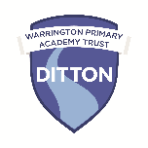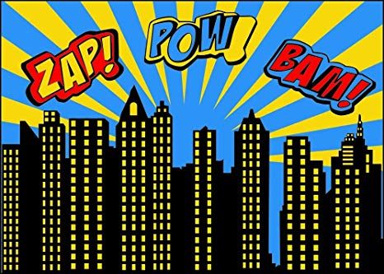

Ditton Primary School

Spring 1 2025

**Expressive Arts and Design**

Children will design their own Supertato puppet using a range of tools and materials. As part of our superhero day we will take on the role of a superhero and design superhero accessories and gadgets selecting correct joining materials. We will create our own stamps and use these to make patterns. We will learn and perform our cores songs Sandy Girl/Boy and Wind the Bobbin Up, moving to music and selecting appropriate instruments. We will be using and composing our own sounds to tell stories. We will follow a musical score to tell this story.

**Physical Development**

In PE we will begin to travel across balancing equipment using different body parts. Talk about movements and actions they observe. We will also talk about the importance of sleep and exercise to keep our bodies healthy. In class we will continue to develop our pencil grip and form recognisable letters.

**Understanding the World**

We will be completing superhero challenges involving changing a range of materials e.g. rescuing toys from melting ice. We will continue to observe the effects of the seasons on our Outdoor environment and Forrest area. Our focus will be real life superheroes and the different occupations in our community e.g. NHS, police etc We will also learn about some real life superheroes from the past such as Rosa Parks. We learn about how Chinese New Year is celebrated. Our RE topic will focus on ‘Special Stories’ and we will learn about the holy books the Bible and the Qur’an. We will also talk about difference and similarities between us when learning about World Religion Day.

**Maths**

We will identify and show the unit of a repeating AB ABC pattern and create our own. We will then create more complex ABB and ABBC patterns and begin to make generalisations about the patterns we create. We will count and order numbers backwards from 10-1. We will be more systematic in our approach to partitioning sets of objects 1-5 including the part whole model. We will begin to learn number bonds to 5. We will use a tens frame and a number track to find one less than. We will use spatial vocabulary e.g. in front, behind, in between, under etc.

**Enrichment Activities**

We will be having a Superhero day in Reception where children can dress up in clothing related to what they would like to be when they grow up.

We will invite the Dental Health nurse to school to discuss how to keep our teeth healthy. We will also have a visit from the Police and we will have a chance to interview the police officers to find out more information about their job role.

**Communication and Language**

We will begin to listen to and talk about non-fiction books we hear read. We will build up a wider vocabulary through describing characters in the books we listen to. In conversation, we will answer and ask questions to develop our own understanding. We will retell a simple superhero story using story language in own words. We will describe events in more detail using first next after.

**Literacy**

This half term, we will be reading ‘Juniper Jupiter’ as our vehicle text. We will read a range of Superhero stories and non-fiction texts about people who help us in the community. We will write captions/simple sentences to retell a story. We will read the story Supertato and write sentences in a letter to thank him for saving the day.

In Steps to Read we will listen to and talk about the differences between stories and information texts. We will make simple predictions about a story based on our knowledge so far of story features. In Phonics we will learn new digraphs, read sentences and write CVC words with digraphs and two-syllables. We will learn to read the tricky words; was, you, they, my, by, all, are, sure, pure.

**Personal, Social and Emotional Development**

We will use Key Group to discuss ways to stay safe when out and about and online and knowing who to go to if we get lost. We will continue to consider ways we manage our feelings and discuss how to resolve conflicts in friendships. We will learn that people have different beliefs and views. This will allow us to discuss ‘respect’ and why it is important to respect ourselves, others and the environment.

**Superheroes**