Year 1 – Computer Skills & In - Knowledge Organiser
Prior Learning: Use various digital technologies, talk about digital devices and relate to real life, digital devices need power to work, controls to turn on and off, write their name using a keyboard on different devices, use simple tools on an interactive whiteboard, use digital technologies with support (using a mouse/trackpad to click), switch on and shut down a computer with support, launch and application by double clicking.

Facts | Vocabulary
1. Moving and resizing windows  - On the tool bar there are some icons that you can use to move and resize the windows.  - You can maximize them so they are full screen or half screen.  - You can minimize them so they are not full screen and you can see your desktop again. | - Maximize – increase the size of.  - Minimize – decrease the size of.  - Shutdown—turning off a computer safely.
2. What is a mouse or trackpad?  • Desktop computers use a mouse which is a hand-held pointing device.  • The movement of the mouse is mirrored into the motion of a pointer on a display.  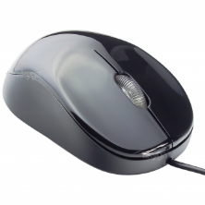  • A laptop uses a trackpad which is a touch-sensitive surface that lets you interact with your laptop through finger gestures.  • It is very much like a mouse, but it is built into the laptop.  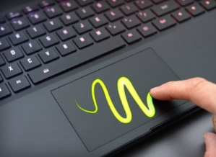  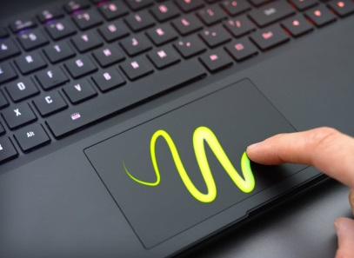 | 3. Saving Documents  • When you have created a document you need to save it.  • Saving a document creates a copy of it in a file that you can then access later.  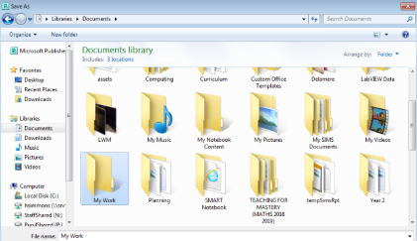  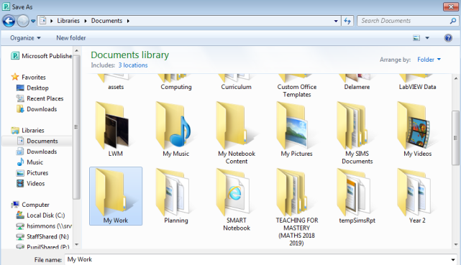
4. What are inputs and outputs?
- Input and output devices are parts of a computer that we can physically see and touch. ​​​​​​​
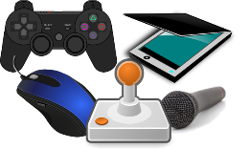
- Input devices are components that put information IN to a computer – so, things like a keyboard, a mouse, a microphone or a webcam.​​​​​​​
- In the image to the right, you can see other input devices that put information into a computer – such as a gamepad, a joystick or a scanner.
- Output devices feed information OUT of a computer – like speakers, a monitor or a printer.
- They are parts of a computer that let the user see or hear the results of the computer’s data processing.

