Year 1 – Digital Art – Knowledge Organiser
Prior Learning: Can independently take photographs/videos, discuss and evaluate work, Can follow teachers’ instructions when using an online interactive program such as paint or draw.

Facts | Vocabulary
1. What is digital art?  - Digital art is work made with digital technology or presented on digital technology.  - It includes images done completely on a computer or hand-drawn images scanned into a computer and finished using software programs.  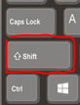  - Some example of digital art are: digital photography, algorithmic art, dynamic painting, 2D or 3D computer graphics, Pixel art, digital collage | 1. Tool – a tool or function on a painting program used to change the area of a canvas by adding paint strokes or colour  2. Copy&Paste – To copy something (on an electronic device) and pasting it somewhere else.  3. Fill – To paint the inside of an enclosed object  4. Erase – Rub out or remove  5. Undo - a feature of a computer program that allows a user to cancel or reverse the last command executed.  6. Manipulate – Making a change to the size, colour or shape of objects  7. Duplicate – make an exact copy of something else  8. Rotate – turning an object in a clockwise or anti clockwise direction
2. Book illustrators that use digital art

- Oliver Jeffers, ‘Here We Are’
- Jim Field, ‘The Squirrels Who Squabbled’

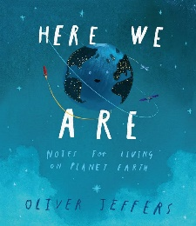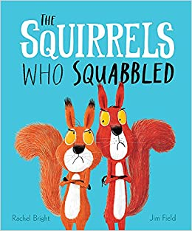

3. Tools (Microsoft Paint)
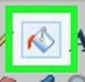
- Toolbar 5. Fill

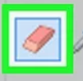
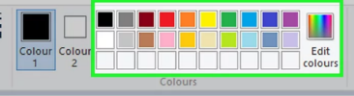
- Choose a colour 6. Erase

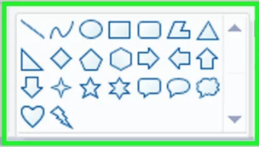
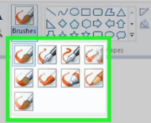
- Choose paintbrush 7. Add a shape

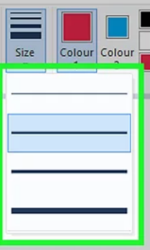
- Line thickness 8. Cut, Copy & Paste
