Year 1 E-Safety Knowledge Organiser
Prior Learning: begin to give reasons why we need to stay safe online, can use the internet with adult supervision to find and retrieve information of interest to them

Facts | Vocabulary
- How is technology used in classrooms, at home and in our communities?  Technology is all around you. You use it in your classroom, at home and in your wider community.  - Classroom – interactive whiteboards, iPads and laptops.  - At home – television, games consoles, mobile phones and washing machines.  - Wider community – self serve tills at the shop, bus timetables on screens and pedestrian crossings. | App – Application (a computer program)  Web Browser – A computer program for reading pages of the World Wide Web.  World Wide Web – The part of the internet that contains websites and webpages.  Internet – A network that connects million of computers across the world.
- What is personal information?  - Personal information is any information that would help to identify you.  - Some examples of personal information are:  - Your name  - Your address  - Name of your school  - Your phone number  - Photos of you and your family  - Passwords  - Adults use their personal information to log into their banking apps so they can keep track of their money.  - You use your personal information to create accounts for games and apps like Roblox and Minecraft.  - Sometimes giving personal information like this to a trusted website like a bank website, or to an app like Roblox is necessary to set up your account. | - Where do I find information?  Web browsers are used by people to find and look at websites on the internet. Search engines are big websites that have billions of pages and make it easy for you to find a website or page in an instant. This is where you can find information.  Some popular search engines are Google, Yahoo!, Bing and Safari. Some child friendly search engines you can use are Kiddle and Kidtopia.
- Why shouldn’t I share personal information?  - If people have access to your personal information, they are able to find you, or can gain access to private accounts using your information such as;  - Online banking accounts  - Facebook Page  - Email accounts  - This means that other people could get access to your money or contact your friends and family.  - If you are being asked for personal information you should tell an adult.  - You can contact the NSPCC (National Society for the Prevention of Cruelty to Children) or Childline if you are worried about something online. | - What is digital footprint?  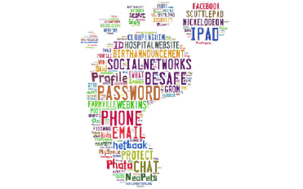  - Everything you do online leaves an invisible trail.  - This includes every photo you post using Facebook, Instagram or Snapchat, every comment you leave and every like you give.  - All these small pieces of information can be put together and tell us a lot about a person.

