Year 1 Knowledge Organiser – Programming with Scratch JR
Prior Learning: Can follow teachers’ instructions when using an online interactive program such as paint or draw, Completes a simple program on electronic devices, Can turn on an iPad, open a program and follow instructions.

Facts | Vocabulary
- What is Scratch JR?  ScratchJr is an introductory programming language that enables young children (ages 5-7) to create their own interactive stories and games. Children snap together graphical programming blocks to make characters move, jump, dance, and sing. Children can modify characters in the paint editor, add their own voices and sounds and then use the programming blocks to make their characters come to life.  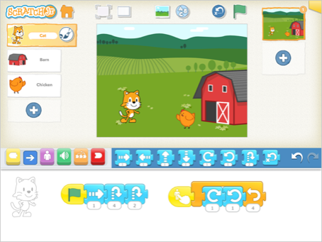  https://www.youtube.com/watch?v=ciWPaEgscr0 - Scratch JR Introduction | Instructions - detailed information about how something should be done or operated.  Debug - finding problems/mistakes in instructions/algorithms and fixing them.  Algorithm - a sequence of instructions that are followed to complete a task.  Programming - designing and building a computer program to accomplish a specific computing result or to perform a specific task.  Sequence - the main logical structure of algorithms. A sequence can contain any number of instructions but each instruction must be run in the order they are presented.  Repeat - do something again once it has already been done  Grow - when something grows in size.  Shrink - when something gets smaller in size.
- Create a character in Scratch JR.  Create a character in Scratch JR.  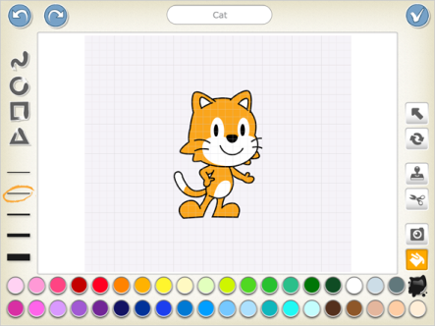  Use the ‘Paint Editor’ tool to create a character. | - Block Categories - ‘Motion Blocks’  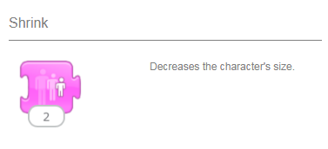  Use the commands to move the character. These blocks are then used to create a sequence of instructions (algorithm) to enable the character to move.  - Independently create a simple programme  Programme the blocks by dragging different blocks into the blocks palette. This is where you connect programming blocks to create scripts, telling the character what to do.
- Block Categories – ‘Look Blocks’
Make changes to the characters size (grow/shrink), add speech, fade character and make it reappear.

