Year 1 – Word Processing Skills Knowledge Organiser
Prior Learning: Write their name using a keyboard on different devices, use shift or caps lock for the initial sound in their name, choose an application to draw with
Facts | Vocabulary
1 - How do I open Microsoft word?  - Double click the Icon on the desktop | - Microsoft Word- Software programme  - Bold- Makes things darker  - Italics- Changes the lettering to italics  - Underline- Underlines the highlighted text  - Enter Key- is used to send the cursor to the next line  - Space Bar- Is used to leave finger spaces between words, just as you would in your writing
2 - How can I format text when using word processing programmes?
While using word processing programs you can format and edit the text in a variety of ways. You can make text:
• Bold
• Italics
• Underlined
3 - Editing Text  It is important to be able to go back and edit a mistake while you are using word processing programs.  - You can navigate back through words using the arrows keys on your keyboard.  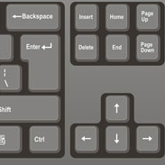  - Once you have found your mistake you can use the backspace or delete keys to delete your mistake and then correct it. | 5 - Space Bar  - Just as you would in your writing, you need to include spaces within typed words on word processing programs.  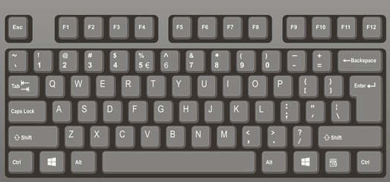  6. Enter Key  - The enter key can be used to send the cursor to the next line.  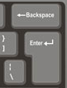  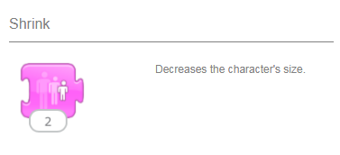
4 - What is the shift key used for?
- The shift key can be used to switch between lower-case and upper-case letters.
- To do this you hold the shift key down while you also press the letter you want to be upper-case.
