Year 2 – Algorithms – Knowledge Organiser
Prior Learning: understand that an algorithm is a set of step-by-step instructions , beginning to check work for mistakes and understand that this is known as ‘debugging’, direct and program a Bee-Bot or other programmable toy, using different end blocks on Scratch JR such as repeat forever, change the size of character, add characters and backgrounds.

Facts | Vocabulary
1. What are quarters turns?  - Quarter turns describe the direction an object will move in.  - They can either be clockwise, or anticlockwise.  - The image below shows a quarter turn clockwise.  - We can also call quarter turns 90 degree turns.  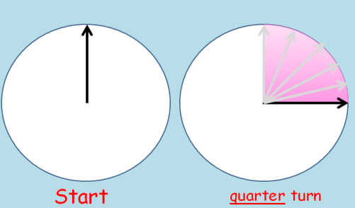  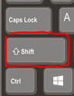 | 1. Quarter turn  2. Degrees  3. Clockwise  4. Anticlockwise
2. What are clockwise and anti-clockwise?  • When something moves in a clockwise direction, it is moving in the same direction as the hands on a clock.  • When something moves in an anti-clockwise direction, it is moving in the opposite direction to as the hands on a clock. | - The red hand is where the minute hand on the clock started, it started on 6.  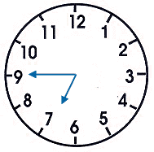  - After moving a quarter turn clockwise it will end up on the 9, where the green minute hand is pointing.  