Year 2 – Data Collection – Knowledge Organiser
Prior Learning: sort objects according to a criteria (Size, colour or shape), count how many people like something particular, using pictorial representations

Facts | Vocabulary
- What is data?  Data is information, we use it every day in a range of different situations. Types of data include:  - Your name  - Address  - Phone numbers  - Favourite colour  - Number of pets  It can come in many different forms:  - Audio  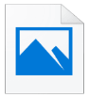  - Video  - Photo  - Text  We need to know different data to help us. In school, we need data so that we know who everyone is and how old they are – if we didn’t have this information then children may be in the wrong class. | Data – information  Survey – a research method used to collect data from a pre-chosen group of people.  Questionnaire – a set of written questions gained to gather information on a specific topic.  Observation – closely observing or monitoring something.  Interview – a meeting of people face to face  Criteria —a characterising trait.  Audio —anything related to sound.  Visual – photos and videos.
- How can we collect data?  We can collect data in a number of different ways. If you’re talking to a friend or a few friends, then you can simply ask them for the data that you want.  In formal situations, observations and interviews may be completed.  If you want to collect information from more people then you can use:  - Surveys  - Questionnaires | - Examining Data  Once you have collected your data you can develop questions and examine the data in detail.  If you had collected data on which pets children in your class had for example, you could examine:  - Which was the most popular pet  - Which was the least popular pet  - Explore the difference between pets  - Look for similarities in data  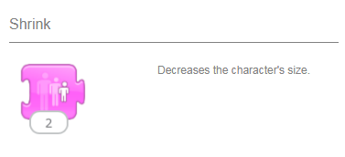
- How can we present data?  Data can be presented in different ways including tables, charts and graphs. Concrete representation can be created using different manipulatives before advancing on to digital versions.  - Tally charts can be used – these are usually done to collect raw data before representing in a formal method  - A pictogram represents data using pictures.  - Bar graphs represent the data using bars. | 