Year 2 – E-Safety Knowledge Organiser
Prior Learning: online and offline, SMART rules, what a web browser is, email is a good form of communication, how to use a search engine to find a picture, personal information should be kept private from strangers online

Facts | Vocabulary
1. Rules when using technology  - To keep you safe online schools, parents and carers usually have a set of rules that you need to follow.  - These might include things like:  - Asking permission before you use it  - Setting a time limit on how long you use it  - Asking before downloading games or apps  - No messaging in online games  - Any rules your school, parents and carers set for you when using technology should be followed for your own safety. | - Permission – allowing someone to do a particular thin or giving consent  - Factual – concerned with what is actually the case or true
2. Who can create content online?  - Anyone can be an author on the internet.  - On some websites like Wikipedia, anyone can edit the information on there without needing permission.  - This means that some information may not be factual or even true.  - You must be careful when using information from the internet and that you can verify how factual it is.  - Anyone with social media accounts like Facebook, Instagram, Twitter, Youtube and TikTok can post things to their social media accounts and create their own content to share. | 4. What is cyber-bullying?  - Cyberbullying is bullying that takes place over digital devices like mobile phones, computers, and tablets.  - Cyberbullying includes sending, posting, or sharing negative, harmful, false, or mean content about someone else.  https://www.youtube.com/watch?v=I6jz8Vmq17E
3. How can technology be used to communicate?  - Technology is changing every day and we are able to use it to communicate with people all over the world.  - You can communicate with your teachers from home using emails or Microsoft Teams if needed to complete your learning.  - You can keep in touch with family members and friends by sending text messages or by having video calls on FaceTime, Facebook Messenger and Zoom.  - You can also have important meetings with doctors and dentists using video calls too.  - You can create social media accounts to create text posts and share photos and videos. You can comment on other people’s and talk to them through chat features. | 5. What should you do if you think you or someone you know is a victim of cyber-bullying?  - The best thing to do is to tell someone.  - Tell a trusted adult such as a parent, carer or teacher. They will try to help you.  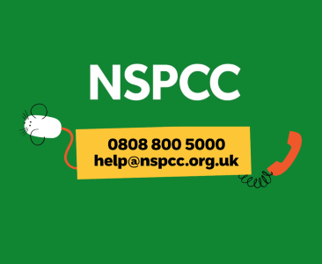  - You can also call Child line or the NSPCC (National Society for the Prevention of Cruelty to Children).

