Year 2 – Programming using Conditionals
Prior Learning:understand that an algorithm is a set of step-by-step instructions , beginning to check work for mistakes and understand that this is known as ‘debugging’, direct and program a Bee-Bot or other programmable toy, using different end blocks on Scratch JR such as repeat forever, change the size of character, add characters and backgrounds.

Facts | Vocabulary
1. Create a sprite and script on Scratch JR.  The scripts area in Scratch JR is where you put your command blocks to control your sprite or sprites. Your set of instructions (algorithm) is called a script in Scratch JR.  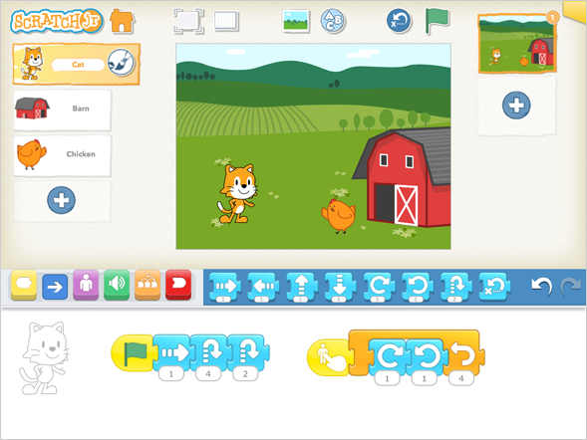  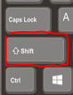 | Instructions - detailed information about how something should be done or operated.  Debug - finding problems/mistakes in instructions/algorithms and fixing them.  Algorithm - a sequence of instructions that are followed to complete a task.  Error - incorrect result produced by a computer.  Conditional - a set of rules that will be performed if a certain condition is met.  Sprite – character created in Scratch JR.  Script – the set of instructions (algorithm) you have created for your sprite.
2.Green Flag Blocks  Green flag blocks are placed at the start of your script (algorithm). When you click it, your script (algorithm) will start. This is one of the ’triggering blocks’ on Scratch.  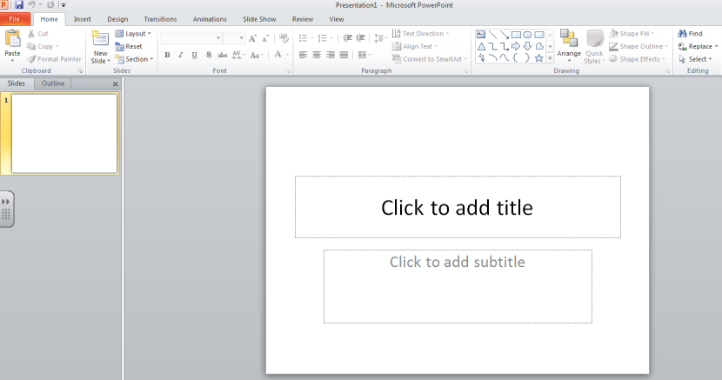  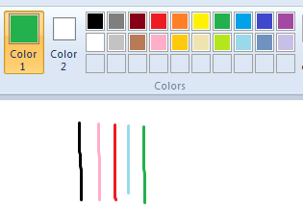 | 4. Conditionals  They are sometimes referred to as ‘if . . . then . . .’ statements. Conditional statements always have an if part, which tells the app what to do when the condition is true.  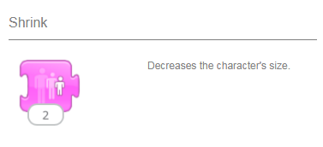  Add a new sprite using the circled section of the
3. Repeat Blocks
Repeat blocks are placed at the end of your script. When your script is running, with the repeat block at the end your script will keep repeating itself over and over again.

