Year 3 – Audio and Movie - Knowledge Organiser
Prior Learning: planning an animation, use a sequence of images to create a short animated sequence, insert and resize pictures, independently take photographs/videos, discuss and evaluate work.

Facts | Vocabulary
1. How to record sound (Windows device)  - On a windows device, open ‘Microsoft Voice Recorder’  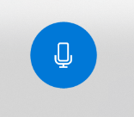  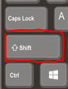  - Click the record button to start  recording  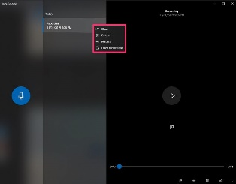  - To stop recording, hit the stop button. The options will appear for you to rename the file, play it back or trim it | 1. Audio – sound, especially when recorded, transmitted, or reproduced.  2. Video – the recording, reproducing, or broadcasting of moving visual images.  3. File – A file is the common storage unit in a computer, and all programs and data are "written" into a file and "read" from a file.  4. Import – Similarly, in computer terminology, "import" means to bring a file from a different program into the one you're using  5. Movie - A movie is an electronic signal of moving graphics, pictures, or text used to combine a steady stream of images
2. How to import pictures/photographs (Windows Video Editor)  - In project library, click ‘+Add’  - Select the photos you want to add to your movie  - Drag photos to your ‘storyboard’ and order them how you want  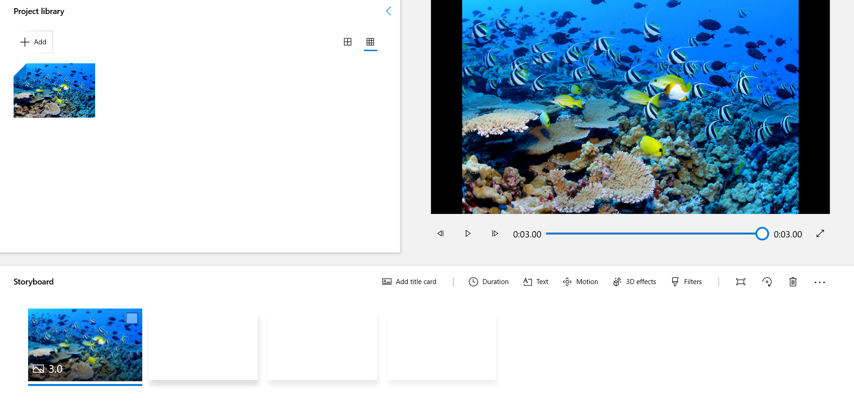 | 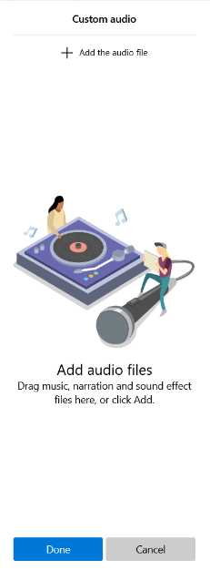  3. How to import a digital recording (Windows Video Editor)  1. Click custom audio  2. Add audio file  3. Select the sound recording/s you  want to add
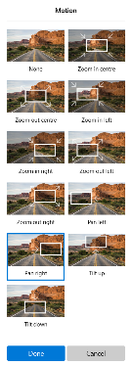
4. How to use pans/zoom (Windows Video Editor)

1. Click ‘Motion’

2. Choose a motion you want to use on the chosen picture/photograph

