Year 3 Internet Research & Networks Knowledge Organiser
Prior Learning: search engines such as Google, Bing and Yahoo, web links, blog posts, online and offline, SMART rules, what a web browser is, email is a good form of communication, how to use a search engine to find a picture, personal information should be kept private from strangers online

Facts | Vocabulary
- What is a network?  - A network is a number of things that are connected together in some way.  - You frequently use networks in everyday life. Some examples of networks you will be familiar with are the railway network and road network.  - Both of those networks connect towns and cities.  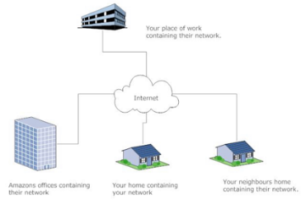 | - search engine – a program that searches for items in a database that link to keywords specified by the user.  - communication – exchanging of information by speaking, writing or other mediums.  - bookmark – a shortcut saved to specific webpage.  - digital footprint – a trail of data you create while using the internet. It includes the websites you visit, emails you send and information you submit online.
- What is the World Wide Web (WWW)?  - Tim Berners-Lee, a British Scientist, invented the World Wide Web (WWW) in 1989 and designed it in 1991.  - It is more commonly known as the web.  - It is a network of online content that is formatted in HTML.  - HTML is the standard language used for documents online. | - How do search engines display your results?  - Search engines sort results to show you the ones they think are the most useful.  - Different search engines use different algorithms. This means that some sites will give their results in a different order, or they may even show completely different results altogether.  - Usually the top links are the most relevant to your search.  - However, it is often worth scrolling down the page because you might find something better further down.  - Sometimes the top links are adverts for companies who have paid to be listed at the top.
- How do search engines work?
- To find what you’re after, a search engine will scan its index of webpages for content related to your search.
- A search engine makes this index using a program called a ‘web crawler’ or ‘web spiders’.
- This automatically browses the web and stores information about the pages it visits.

