Year 3 – Presentation Skills Knowledge Organiser
Prior Learning: type with two hands, shift/space/enter, undo/redo, make text bold/italic/underlined, save work in a folder, edit text using backspace/delete/arrow keys, format text, select single words.

Facts | Vocabulary
1. What is a presentation on Microsoft PowerPoint?  - A presentation on PowerPoint is a collection of individual slides that contain information on a topic.  - Information is organised onto each slide.  - These are commonly used by businesses for meetings and for teachers during lessons.  - They are visual to make the talk more engaging.  - The presenter should not read directly from the slides, otherwise the presentation could disengage the audience.  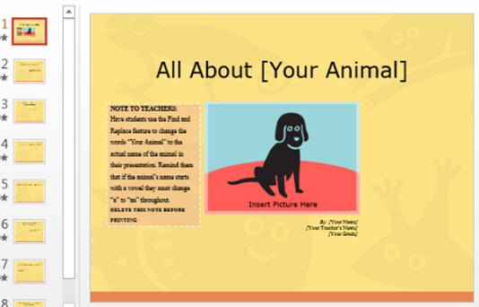 | 1. Presentation – the organisation of ideas.  2. Slide—a single screen in a presentation.  3. Reorder—change the order of something.  4. Font – the style of the letters.  5. Underlining – forming a line under text.  6. Size – how large the lettering is.  7. Colour – the shade of lettering.  8. Image – a picture or photo.  9. Save – to keep a document safe.  10. Transition – the change from one image in a slide show to the next.  11. Insert – to add slides or text.  12. Files – a folder where documents are saved.  13. Layout – the structure of presentation.
2. What are PowerPoints used for?  - Businesses – to pitch a product to a company to buy it or to explain developments.  - College/University Lecturers and teachers – to teach students about a particular topic.  - Students – to create slide show presentations to teach others or show what they have learnt.  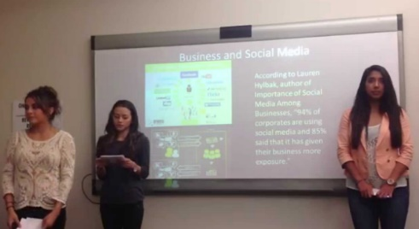  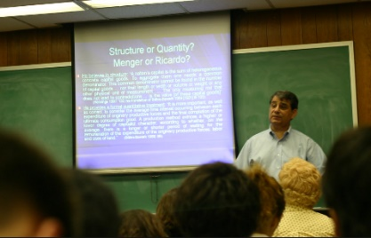 | 3. What does a presentation look like?  - To open Microsoft PowerPoint, you open this red symbol on the desktop/laptop.  - You can see all of your slides down the left hand side of your screen.  - When you click on one of the small versions of your slides it shows you that slide in full screen.  - You can add and format text in the same way you do using word processing programs, such as changing the text to bold, italics and underlining.  - Make sure the text is readable with appropriate colours and fonts.  - Slide transitions can be added for effect.  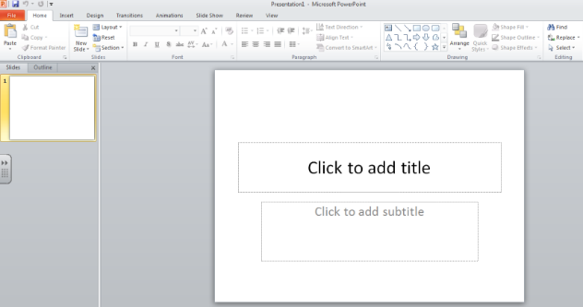  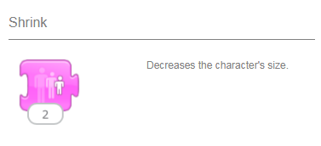
4. How can I add images to PowerPoint?  - Images can be added to PowerPoints to make the information more appealing to look at, to demonstrate models and to put information into context.  - To upload an image, you can either copy and paste an image from an online search engine such as Kidtopia or select the ‘picture’ tab on the header bar.  - Images should be relevant to the information and be kept to a minimum so the audience is not distracted from the presentation.  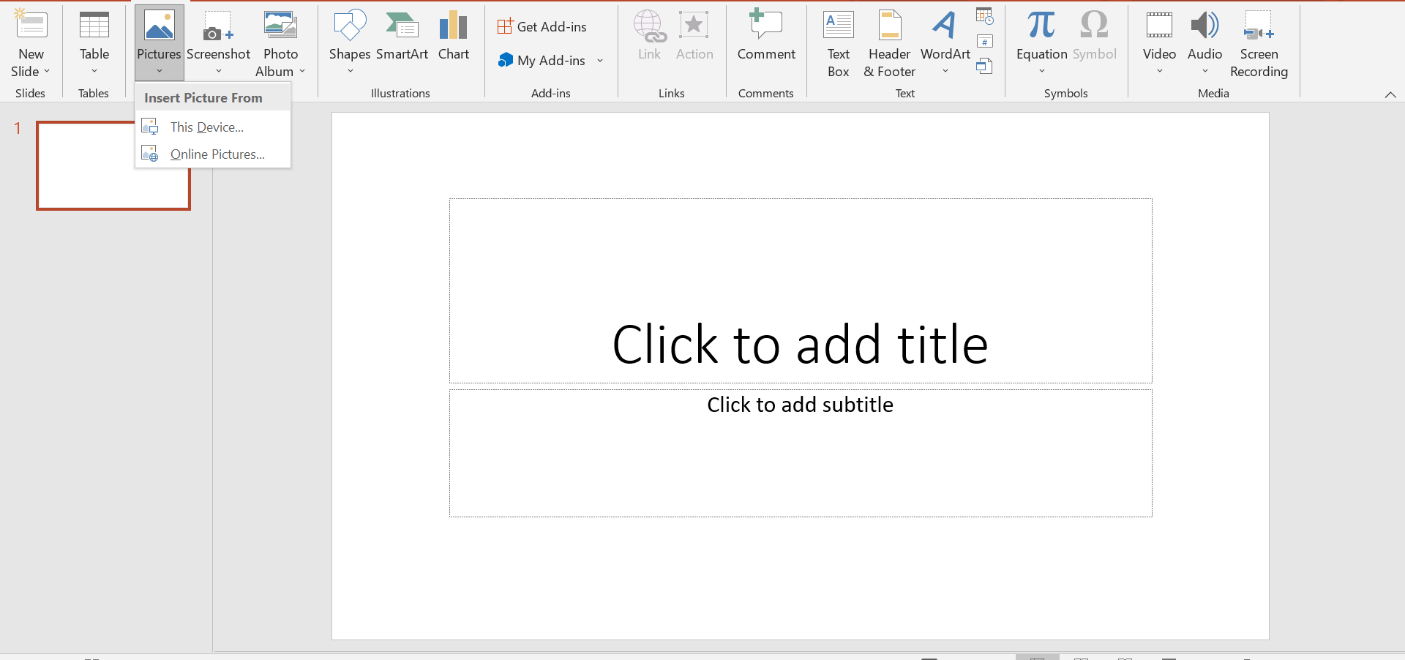 | 5. How can I save my PowerPoint?  - When you are ready to save your PowerPoint, the ‘file’ tab needs to be clicked. From here, the ‘save as’ tab needs to be clicked if it is a new presentation.  - You must save your PowerPoint into an organised folder so you are able to discover it later on.  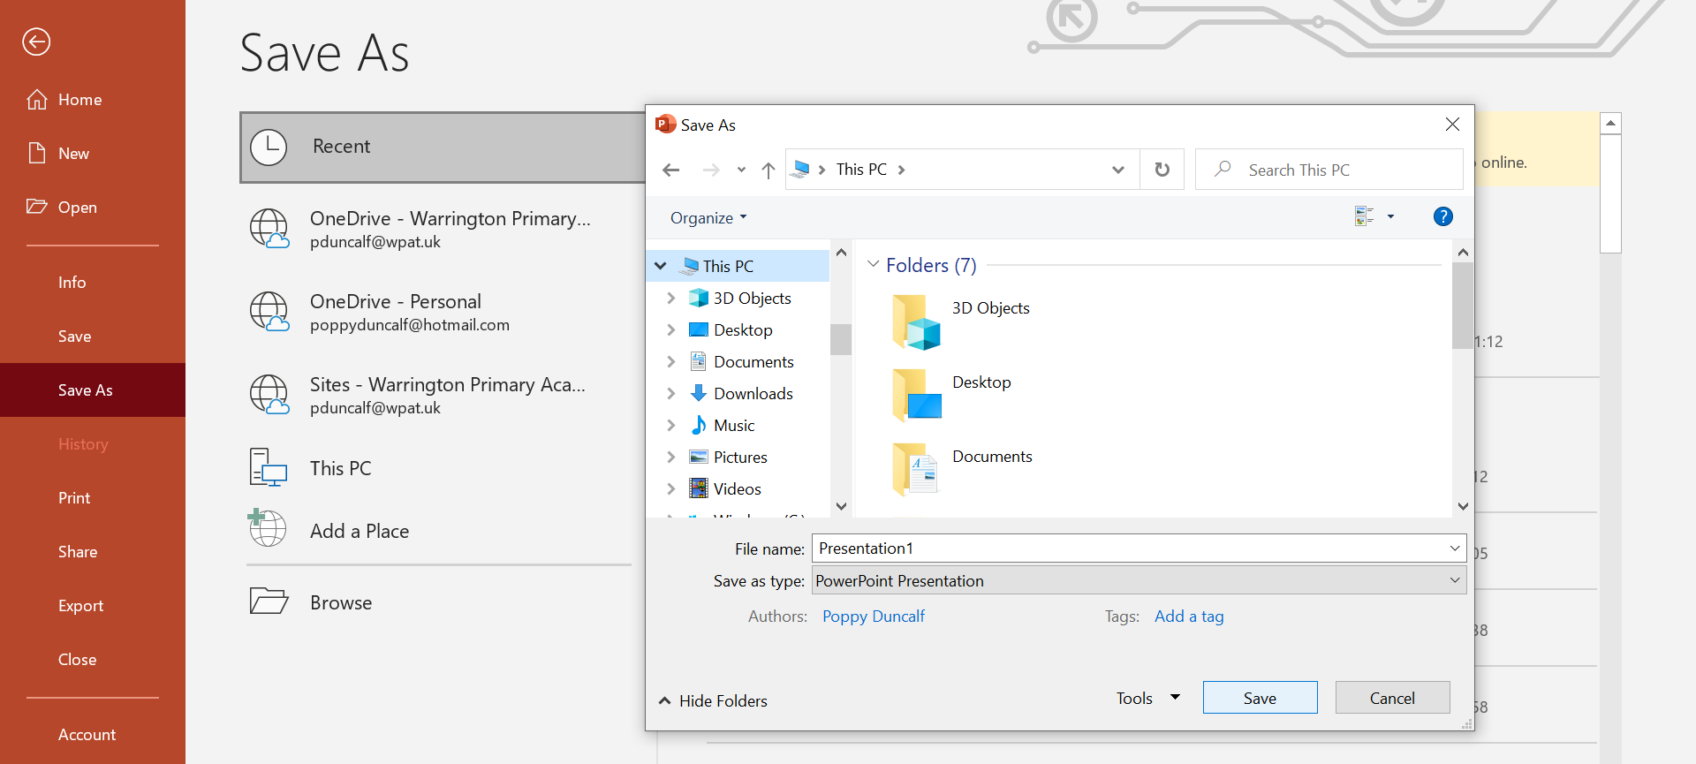  - Once the PowerPoint has been saved once, the easily accessible save key in the top left corner can be pressed from now on.
Youtube:

https://www.youtube.com/watch?v=KBTvPpGmNc4 - Creating a powerpoint presentation for kids

https://www.youtube.com/watch?v=Ioog1IyDuRE - Google slides introduction for kids

