Year 3 Programming 2 (Using Scratch)
Prior Learning: instructions as algorithms, instructional language, understanding ‘debug’ as correcting mistakes in programing, programming a beebot, positional language

Facts | Vocabulary
- What is a command?  A command is an instruction given by a user telling a computer to do something, such as run a program.  Commands are usually issued by typing them in or inserting a command ‘block’. | - abbreviations – a shortened form of a word or phrase.  - accuracy – being correct or precise.  - degrees – a unit of measurement of angles.  - predict – say or estimate that a specified thing will happen in the future or will be a consequence of something.
- What does a command look like?  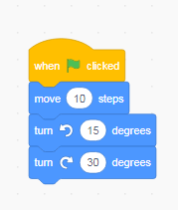  A simple sequence of commands used in Scratch. – When the flag is clicked, the sprite will move 10 steps, turn right 15 degrees and left 30 degrees. | 4 . Using pen function is Scratch  The pen function is an add on that allows a drawing to be made.  It shows the path travelled by a sprite.  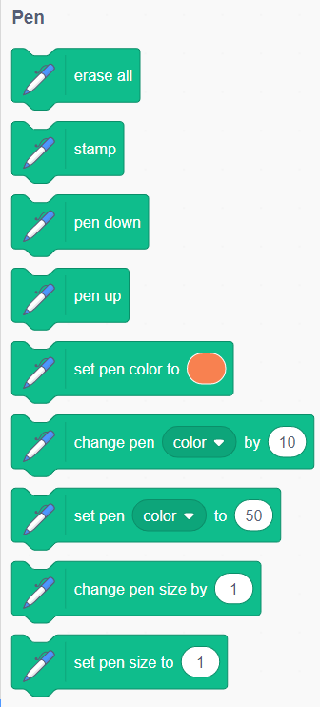  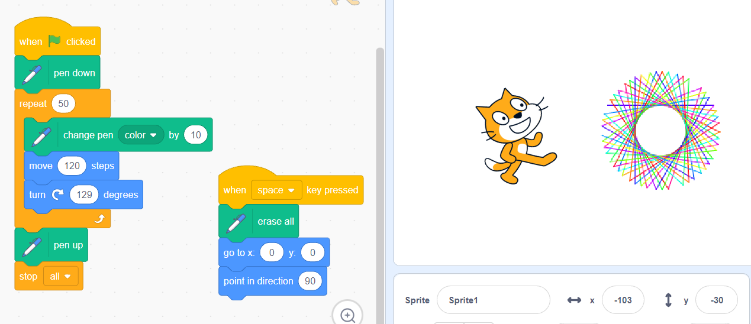
- How degrees and direction are used in coding:

Distance and angles can be used to alter the direction in a sequence of commands. Degrees are used to measure angles and can be used in simple commands. Programs exist in 2D and operate on a grid.
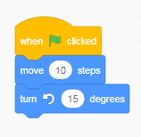
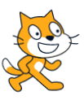
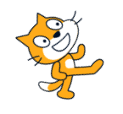

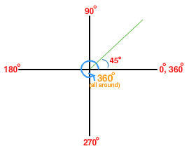
Youtube:

https://www.youtube.com/watch?v=8Gxmvizdi9o – understanding degrees and direction

