Year 4 – Animation – Knowledge Organiser
Prior Learning: acquire, retrieve and store images, modify images in a paint program uses various tools for purpose, create a sequence of images to form a stop motion animation or slideshow

Facts | Vocabulary
1. What are the different types of animation?  Some of the main types of animation use are:  - Traditional animation—2D and hand drawn.  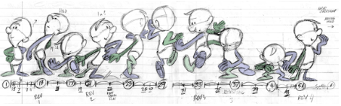  - 2D animation—vector based  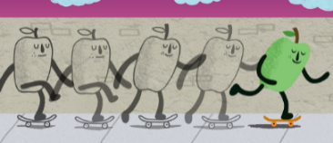  - 3D animation—computer animation and CGI  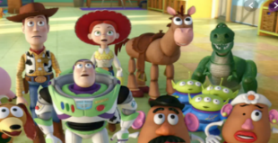  - Stop motion—Claymation and cut-outs.  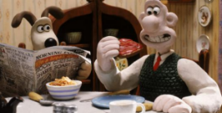  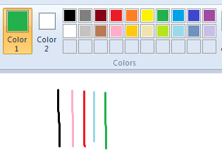  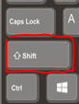 | 1. Onion skinning - A process where the shadow image of the previous frame is present to help you line up the objects of the animation correctly.  2. Refine - make minor changes so as to improve or clarify  3. Claymation – animation of models constructed from clay  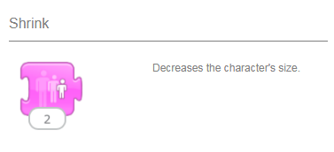
3. History of animation

Before animation was widely understood, there were many inventions and devices that fascinated people by seeming to merge images or make them appear to move. Some of these have complicated sounding names.
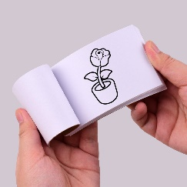
- Thaumatrope
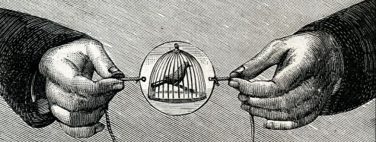

- Flipbook

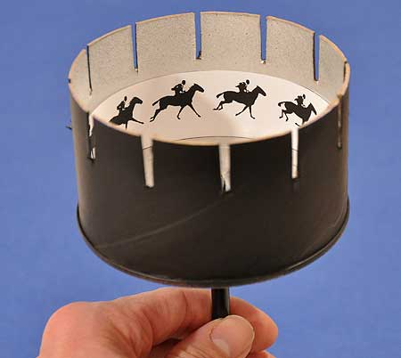
- Zoetrope
2. Who is J. Stuart Blackton?

- British-born U.S. film director and producer who introduced animation and other important film techniques that helped shape and stimulate the development of cinematic art.

- He created the first animated film in America.

- Humorous Phases of Funny Faces is a silent film of J. Stuart Blackton released in the year 1906,
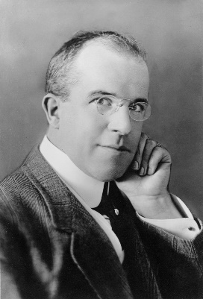

4. Time slider  Timing is important in an animation. The time slider always represents 100% of the total playtime of a clip. This helps to give an idea of where you are in a clip at a quick glance.  You can also use the time slider to jump to any position in the timeline of a clip by dragging the slider to any desired place.  The slider is a useful tool for returning to a place at some point in your animation in order to change, edit or insert a new object.  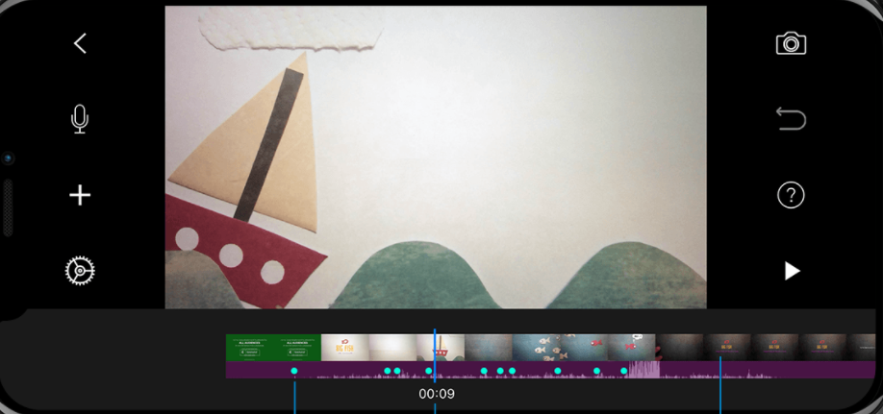 | 5 .Claymation  https://www.bbc.co.uk/teach/class-clips-video/art-and-design-ks2-stop-motion-animation/zr67kmn  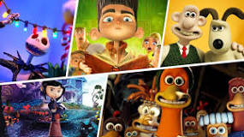  Claymation is a form of stop-motion animation where each animated piece, including characters and some backgrounds, is constructed out of a malleable substance, which is typically plasticine clay. Each frame is recorded on film and then played back in quick succession to give the appearance of movement.

