Year 4 Publisher Knowledge Organiser
Prior Learning: insert slides, add and type in a text box, create folders, print files, add images, format text and text boxes, save files in organised folder structures, search for files on the computer, set windows side by side, format images, reorder slides and present information, slide transitions, hyperlinks
Facts | Vocabulary
- How is Microsoft Publisher similar to Microsoft Word?  - Formatting tools can be used to edit your Publisher document. This includes:  - Background colour  - Size of text  - Font of text  - Images  - Word Art  - Text boxes  - Header and footer  - Hyperlink  - You will be able to apply all of your prior knowledge from Microsoft Word into the Publisher program. | - Publication – a program from Microsoft to design a range of publications.  - Categories – a division of subjects or topics.  - Background designs – the colour of the background.  - Colour designs – the colour scheme applied to a design.  - Gradient – the position of colours across a page.
- How can I choose a design template on Publisher?  - Open the Publisher app.  - Click ‘more templates’ and choose the desired category, for example, invitation cards, newsletters or brochures.  - Choose the specific template you want and click ‘create’.  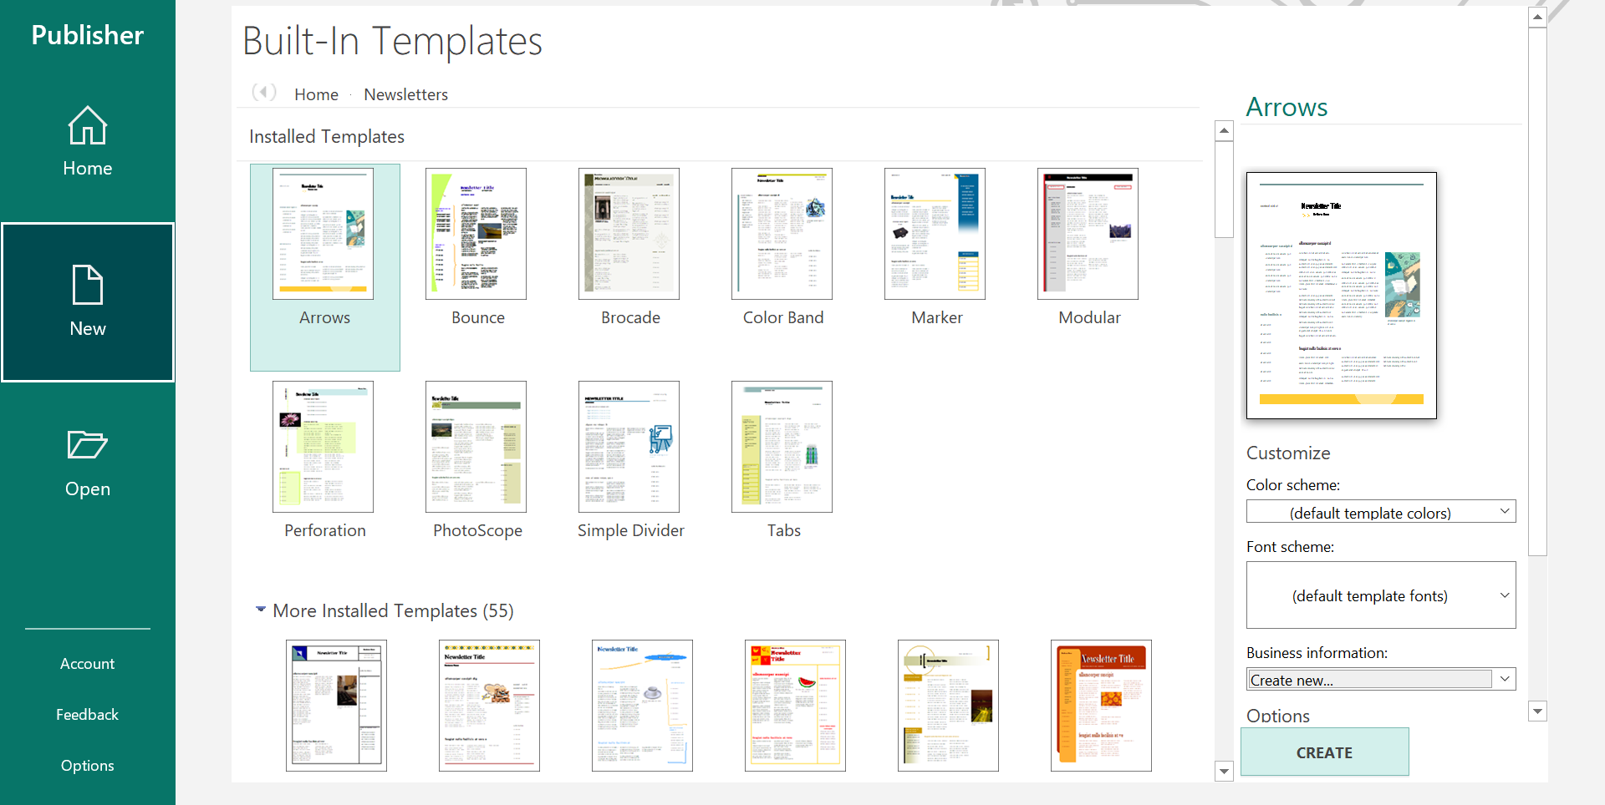 | - How can I edit a pre-designed template on Publisher?  - Colour schemes and background colours can be edited on a template.  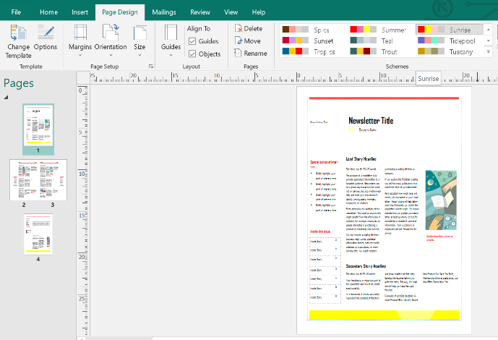  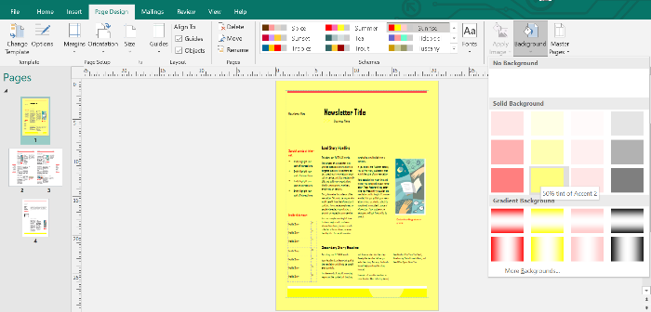  - Click ‘page design’ and choose the colour scheme of choice.  - The background colour can be changed and a gradient can also be applied.

