Year 4 – Programming
Prior Learning: instructions as algorithms, instructional language, understanding ‘debug’ as correcting mistakes in programing

Facts | Vocabulary
- What is an algorithm?  - An algorithm must follow a logical sequence.  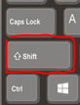  - A sequence is a series of logical steps that must be carried out in a specific order. | 1. Variable  2. Loop  3. Repeat
- What is a variable?  - A variable is something that can be changed.  - In computer programming we use variables to store information that might change and can be used later in our program.  - Variables could be used to store the score in a game, the number of cars in a car park or the cost of items on a till.  - If you were programming a computer game, you could make a variable called ‘score’. This would store information about the number of points you have won during a game.  - A supermarket till uses variables to store information about all the items you buy. As more items are scanned the variable’s total would increase.  - Automated barriers in a car park use variables to count cars in and out. These can then be used to see if there is any space to let more cars in.  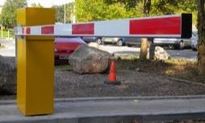  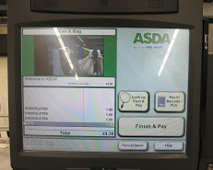 | 3. What is a loop?  - A loop is a sequence of instruction s that is continually repeated until a certain condition is reached.  - We use repeated instructions in everyday life such as brushing teeth, dance moves and sports.  - Count control loops – have a counter that determines how long the loop lasts  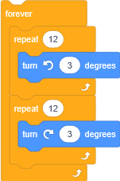  - Forever loops – run until the program is stopped.
4. Order in Loops

The order of the instructions in a loop is important and so is the number of instructions.

The more instructions there are the longer the code takes to run.

If the instructions are out of order then the loop will run incorrectly.
Youtube:
https://youtu.be/xPlGz7WPYH4

Variables in Playlab

