Year 4 Word Processing Skills Knowledge Organiser
Prior Learning: Typing, using shift/space/enter/delete/arrow keys, changing txt (bold, underline, italic), changing fonts.

Facts | Vocabulary
- How can I change the layout of the word document?  - A word document has several functions to choose from.  - One of these involves the layout. Documents can be changed to portrait and landscape mode to change the direction of the page.  - The size of margins can be altered to increase/decrease the size of the page.  - Headers and footers can be added for addiotnal information above/below the main text.  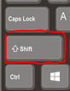  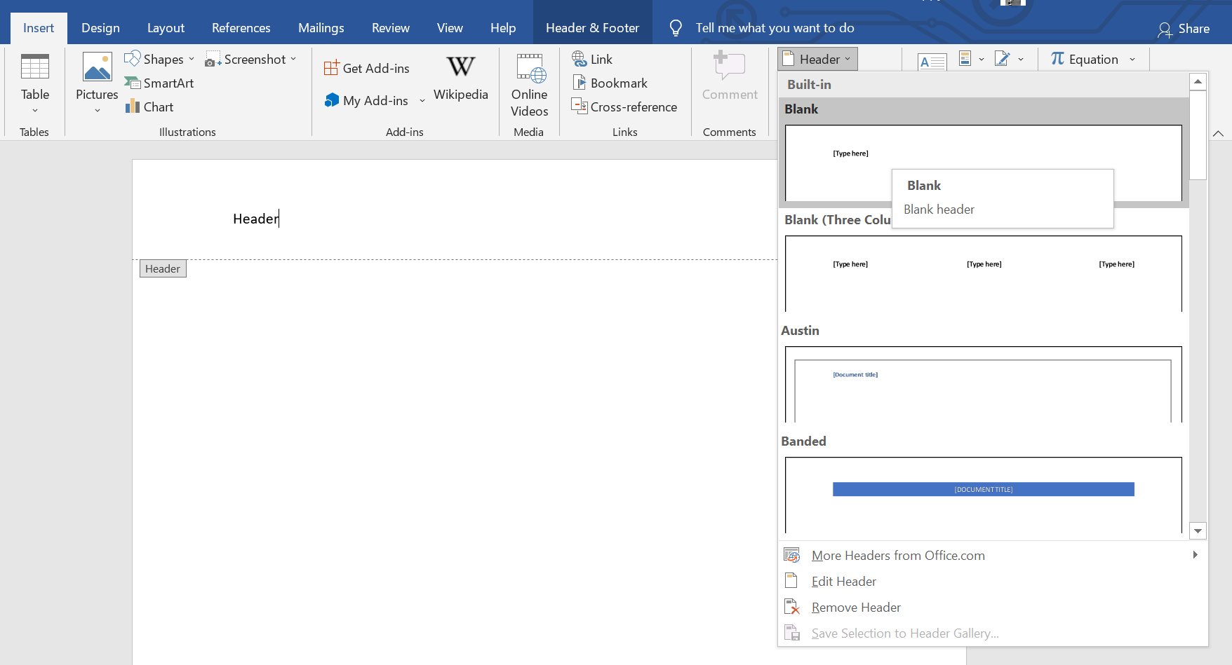 | - Formatting tools – a feature that can change the page layout and page size.  - Orientation – portrait or landscape page layout.  - Headers – the top margin on a word document.  - Footers – the bottom margin on a word document.  - Margins – changing the size of the page.  - Spell check – checking the spellings of text is correct.  - Wrap text – a feature that prevents the image from interfering with the line spacing.  - Table – a feature to present data; typically, numerical data.  - Shortcuts – keyboard controls to edit text quickly.  - Hyperlink – a direct link to a website.  - Printing – sending the document to a printer to have a physical copy.
4. How can I use keyboard shortcuts?
- Keyboard shortcuts are a combination of keys that allow the user quick access to a particular function.
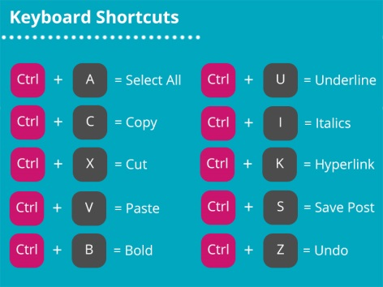

- How can I check my spellings are correct?  - Spell check can be used to correct misspelled words.  - Spell check is useful for those who type quickly and make spelling mistakes and want to effectively fix it. It is also useful for those who don’t know how to spell certain words.  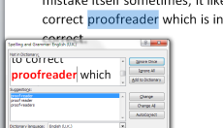 | 5. How can a table be inserted?  - Tables can be inserted to present text information and/or numerical data.  6. How can I add a hyperlink to my word document?  - Hyperlinks can be added so that the reader can click on the link and it will take them directly to a website.  - To do this, click on the ‘insert’ tab, ‘link’ and type in a web address in the ‘address’ box. Press ‘ok’ and the hyperlink will appear on the word document.  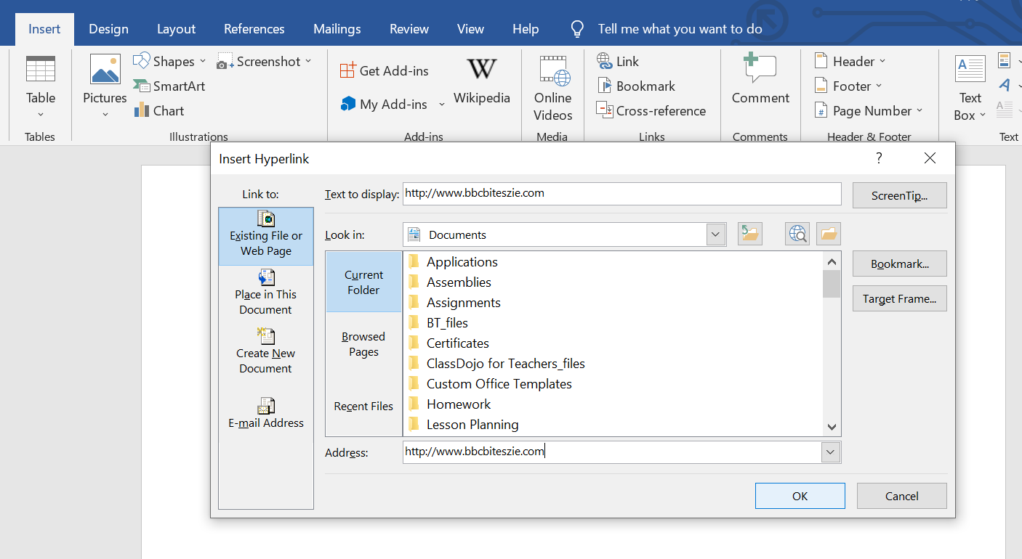  http://www.bbcbiteszie.com  - To save a document as a PDF, follow the strategy to save a typical document, click down the ‘save as’ bar under the document name and select ‘PDF’. From here, a document can be printed.  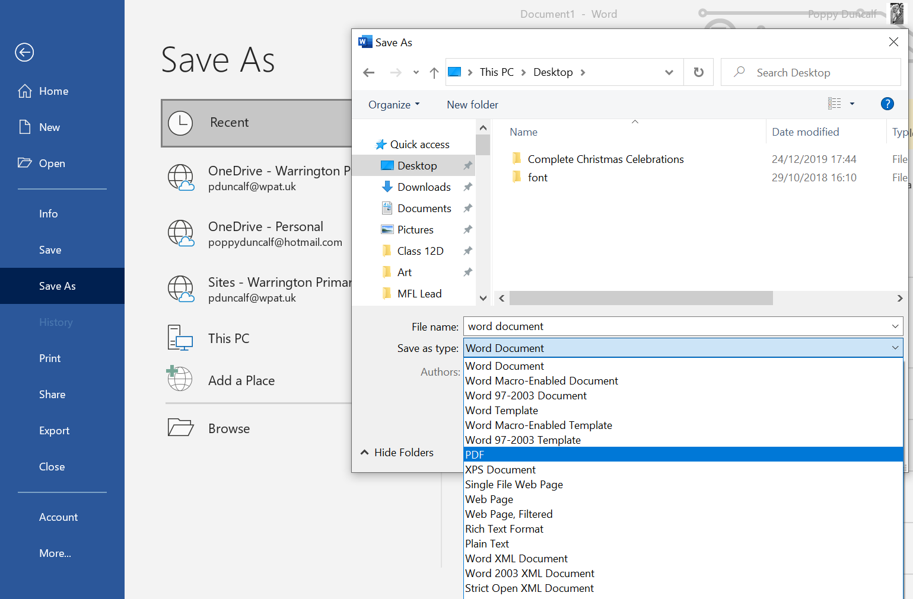
- Why won’t my image move across the document with ease?
- Sometimes on word document, you may want an image to move to a particular place on the page. The images will not move around easily unless ‘wrap text’ has been applied.
- A variety of ‘wrap texts’ can be chosen from such as allowing the picture to be placed behind or in front of text.
- Effects to images can also be added such as changing the colour of their outline or to give the image a shadow behind it. This effect can make images appear in a 3D format.
