Year 5 – Audio and Podcasts Knowledge Organiser
Prior Learning: Record and playback audio, save recordings as files, import audio into movie making software

Facts | Vocabulary
1. What is a podcast?  - A podcast is downloadable broadcast or program, which can include video, music or speech.  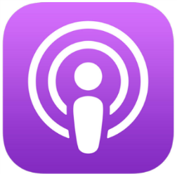  - It is in digital form and is playable on a computer device like a phone or tablet. | 1. Import—to bring a file from one document into another document you are using.  2. Export – To save a copy of a database, image or video into a file format required by a different application  3. Software—the programs and other operating information used by a computer.  4. Record—convert sound into a broadcast.  5. Combine - join or merge to form a single unit.  6. Quality—the standard of something as measured against other things of a similar kind.
2. What makes a good podcast?  1. Keep it short, if it is too long it may lose listeners’ attention.  2. Make it interesting. Choose your topic carefully.  3. Always speak clearly and confidently.  4. Include an appropriate introduction.  5. Vary your tone of voice as this will create a better listening experience. | Popular podcasts for children:  - Story Quest  - Goodnight stories for Rebel Girls
3. How to record audio (Using Audacity)  1. Ensure microphone is plugged in or enabled  2. Click on the red record button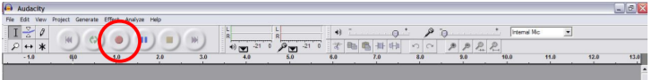  3. Speak into the microphone  4. To stop recording, press square button | 4. How to import audio (Audacity)  1. Click File  2. Click import  3. Click audio  4. Select the file you want to import and click open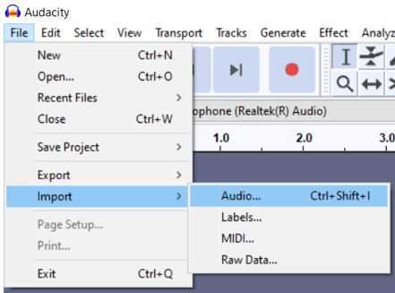  Audacity can import WAV, AIFF, AU, IRCAM, MP3 and OGG files.
5. How to save audio (Using Audacity)  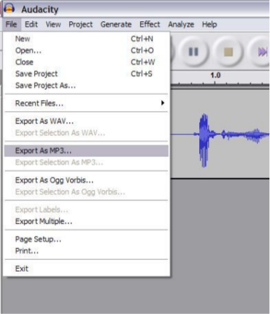  1. Click File  2. Click ‘Export as MP3’  3.Choose a filename and location | Youtube:  https://www.youtube.com/watch?v=le3qPEeaRiM - What is a podcast?  