Year 5 – Programming
Prior Learning: instructions as algorithms, instructional language, understanding ‘debug’ as correcting mistakes in programing.

Facts | Vocabulary
1. What is coding language?  - A coding or programming language is a computer language programmers use to develop software programs, scripts of other sets of instructions for computers to follow.  - There are lots of different coding languages to choose from but some popular choices for children are:  ♦ Scratch  ♦ Python  ♦ JavaScript  ♦ Blockly  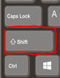 | 1. Translation– moving something from one place to another, moving something from one programming language to another.  2. Target audience—the group at which a product is aimed at.
2. Code within my computer  - Computer code or program code is the set of instructions forming a computer program which is executed by a computer.  - It is one of two components of the software which runs on computer hardware, the other being the data.  - Movements on your screen are translated into codes and algorithms that are written and in place to help control your computer.  - Everything you do on a computer will be translated into codes or algorithms.  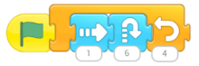 | 3. Coding with different languages  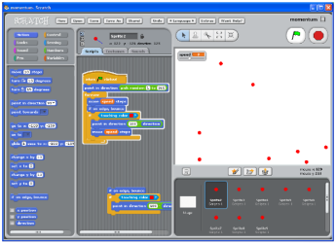  Scratch  Blockly  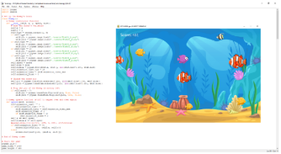  Python  Different languages have different advantages  Python is more customisable and is used on more devices – Raspberry Pi uses Python and is able to do a wide range of jobs, such as running tests, playing games, streaming TV etc.  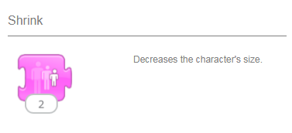
4. If…Then…. Statements

If…then… statements are parts of the code that are used to control variables and commands.

We pose a true or false statement (if)
An action happens if the statement is true (then)

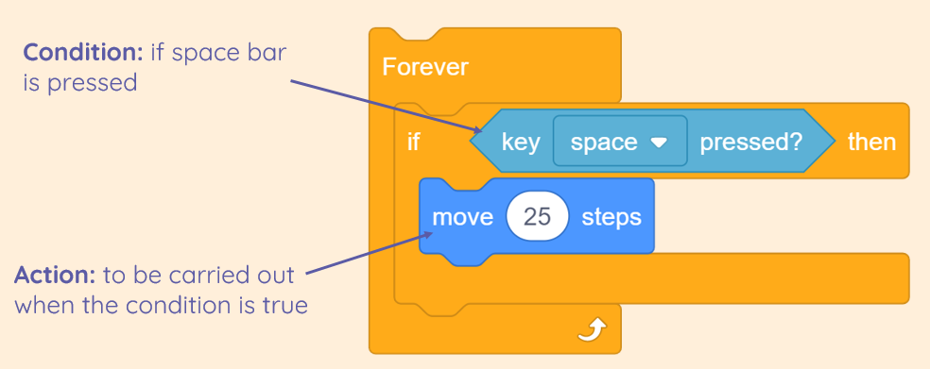
Youtube:

https://www.youtube.com/watch?v=Nc31NAujTkA - Computer programming and coding/programming languages

