Year 5 – Spreadsheets – Knowledge Organiser
Prior Learning: data collection, pictograms, bar graphs/charts, understanding data, answering questions based on data

Facts | Vocabulary
1. What is a spreadsheet?  - A spreadsheet is a powerful tool for organising information.  - They can be used to carry out calculations quickly and to store large amounts of information for a range of purposes.  - This information can be represented using different graphs and charts. | Spreadsheet – an electronic document in which data is arranged in the rows and columns of a grid and can be manipulated and used in calculations.  Cell – A cell is a rectangular area formed by the intersection of a column and a row.  Formula – A formula is an equation that makes calculations based on the data in your spreadsheet.  Discrete – Discrete data is information that can only take certain values.  Continuous – continuous data can take any value, there are an infinite number of possible outcomes.  Field – Each item of information in a database record, such as a telephone number or street number, is referred to as a field.
2. Inputting Data  - Everything in a spreadsheet goes into a cell. Each cell is named by the row and column in which it is located. Cells can be formatted to look clearer or more interesting, similar to word processing or desk top publishing.  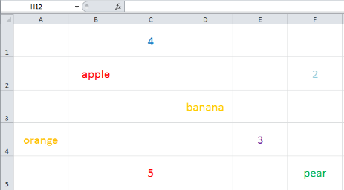  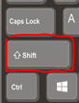  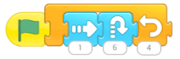  - The top of each column of the table has a title, this is known as a field and will require a specific type of data format such as:  - Text  - Number  - Data  - Money | 4. Creating graphs to present data:  - A number of different graphs can be created to present your data. These allow the user to clearly see the data and supports with analysis.  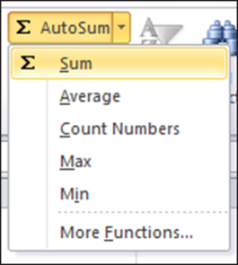  Graphs and pie charts can be used to display discrete data.  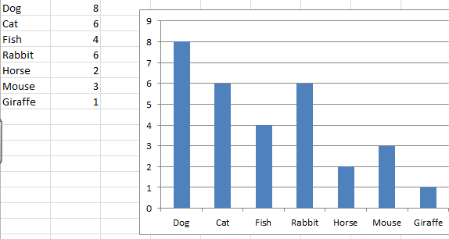  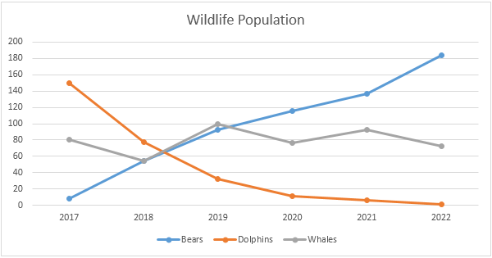  Line graphs can be used to represent continuous data.
3. Making calculations using spreadsheets

- One advantage of spreadsheets is the ability to do calculations quickly, this is done using different formulas.
- The SUM function can be used add, subtract, multiply and divide cells.
- Functions can be selected from the formula bar.
- A formula is always shown by using the ‘=‘ sign first.
- The calculation goes inside the brackets.

Other functions you can use are AVERAGE, MIN and MAX.

