Year 6 – Databases – Knowledge Organiser
Prior Learning: to understand that ICT can be used to store and sort information, to add a record to a file in a database, to produce bar charts from a database, to sort and classify information using a database.

Facts | Vocabulary
- What is a database?  - A database is a system that makes it easy to search, select and store information. Previously they would have been paper based though in recent years have been digitised.  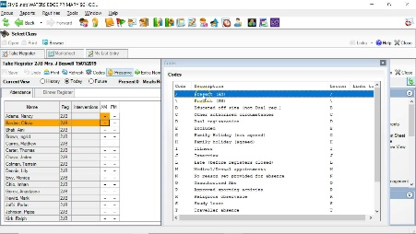  - Databases are used in many different places.  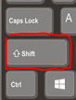  - School’s use them to keep records of all children; this includes personal information and records of attendance. | Field – Each item of information in a database record, such as a telephone number or street number, is referred to as a field.  Record – an entry within a database that contains one or more values  Filter – using a set of criteria to reduce the amount of items in a group  Search - the systematic retrieval of information, or the facility for this.
- Creating records  - Databases store data in tables. Tables are made up of records, and records are made up of fields. A hospital might use a database to keep records of its patients. A patient’s record may contain the follow fields:  - First name  - Last name  - Height  - Diagnosis  - Release Date | - Completing Searches  Searches can be used to find to find a particular record. They can be used similarly to filters but are usually more specific.  ‘OR’ searches  You can run more complex searches on your database by using the ‘or’ function.  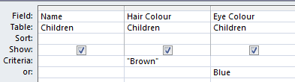  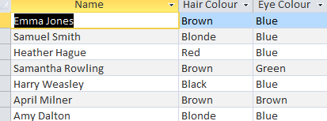  When the query is run, it will pull out all of the children who have brown hair OR who have blue eyes.  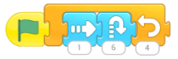  ‘AND’ Searches  You can also run queries that will filter you data to find a given field AND another.  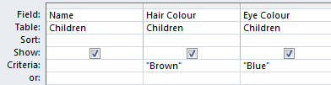  When the query is run, it will pull out all of the children who have brown hair AND blue eyes.  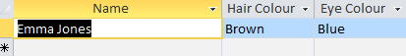  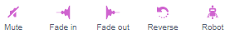
- Filtering and sorting information

- Databases can be easily manipulated to allow the user to see specific information by using filters and searches.
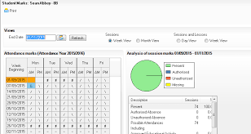
- You can filter information based on the fields within the record.

- For instance, a teacher may choose to filter the information on their class based on children’s attendance. The filter would allow the teacher to see children who fit the criteria set, so those above 95% attendance.

- You can also sort the records in a database.

- When sorting, all records in a particular group will be shown though the order will be based on the criteria.

