Year 6 – Presentations using Google Slides Knowledge Organiser
Prior Learning: ability to plan the structure of a document/presentation, ability to select and import graphics to use in documents, create hyperlinks to produce a non-linear presentation, use multimedia programs to organise, refine and present information.

Facts | Vocabulary
- How to open Google Slides  In the Google search bar you need to search for ‘Google Slides’ and sign in using a gmail account.  Click on the ‘blank’ template to begin a new presentation. | Google Slides – a presentation program on the web browser Google.  Presentations – a speech or talk in which a new product, idea, or piece of work is shown and explained to an audience.  Audience – the assembled spectators or listeners at a public event.  Keyboard shortcuts – a key or combination of keys providing quick access to a particular function within a computer program.  Self and peer assessment - students assess each other and themselves, which can encourage students to take greater responsibility for their learning.  Animations – an effect to move objects on the presentation.
- What are Google Slides useful for?  - Google Slides is a similar software to Microsoft Powerpoint.  - The software is popular with businesses, college/University Lecturers/teachers and students.  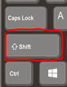  - Each consumer is demonstrating information through a visual, presentation program. | - How to use keyboard shortcuts on Google Slides  - Knowing some basic keyboard shortcuts can save you a lot of time when carrying out simple tasks on a computer.  - Control+C lets you copy any line of text or photos to your clipboard, while keeping a copy of the text in its original location.  - Control+V lets you paste any text you have copied to your clipboard.  - Command+W is the quickest way to close the current tab in your browser.  - Control+Z lets you undo whatever it is you just did.  - Control+S will save your work. Make hitting this combo a habit and you will be protected if your power dies or some other bug causes your computer to crash.  7. How to create a transition  - Click ‘transitions’ on the tab above the presentation. A drop down bar will appear on the right hand side of the screen.  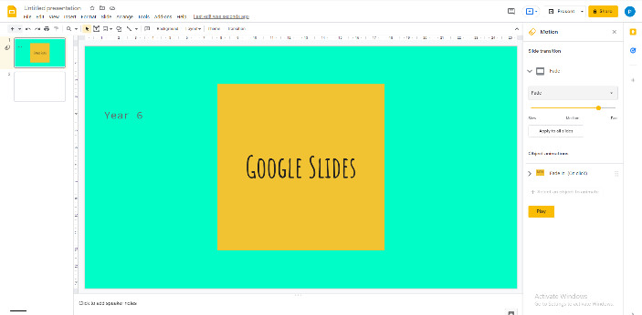  - You can choose to create slide transitions or object animations to move the objects on the screen.  8. How to save your Google Slides Presentation  - A Google Slides presentation must be downloaded into Microsoft PowerPoint if wanting to save onto a desktop/laptop. Otherwise the presentation will save to the gmail account.  - Click ‘file’, ‘download’ and ‘Microsoft PowerPoint’. This will download the presentation into Microsoft and open the program up. Here you can save it via Microsoft PowerPoint onto the desktop.  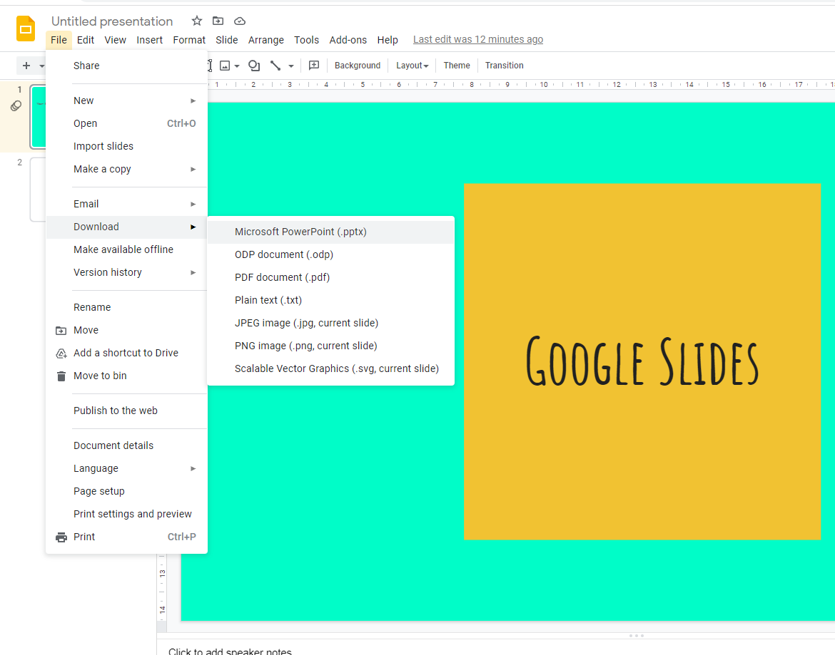
  - Tips for making effective presentations:
- Plan carefully—have an idea of exactly what you want to include before you begin creating.
- Do your research—presentations are made to be seen by other people, you will therefore want to ensure you have all your facts correct.
- Know your audience—consider your target audience carefully and try to ensure the content is appropriate.

5. How to create a presentation on Google Slides
- On the right hand side, a drop down bar of ‘themes’ appears when opening the blank template. Here a colour/font theme can be chosen.
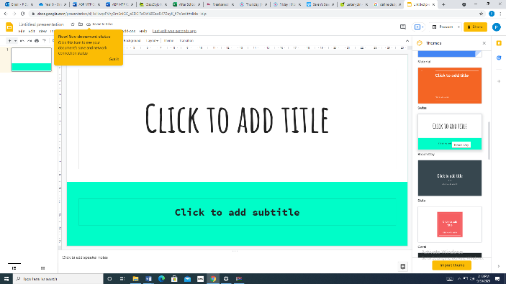

- To create a new slide, right click on the mouse to bring up a selection of options. Choose the option ‘new slide’. This action can be repeated for as many slides needed.
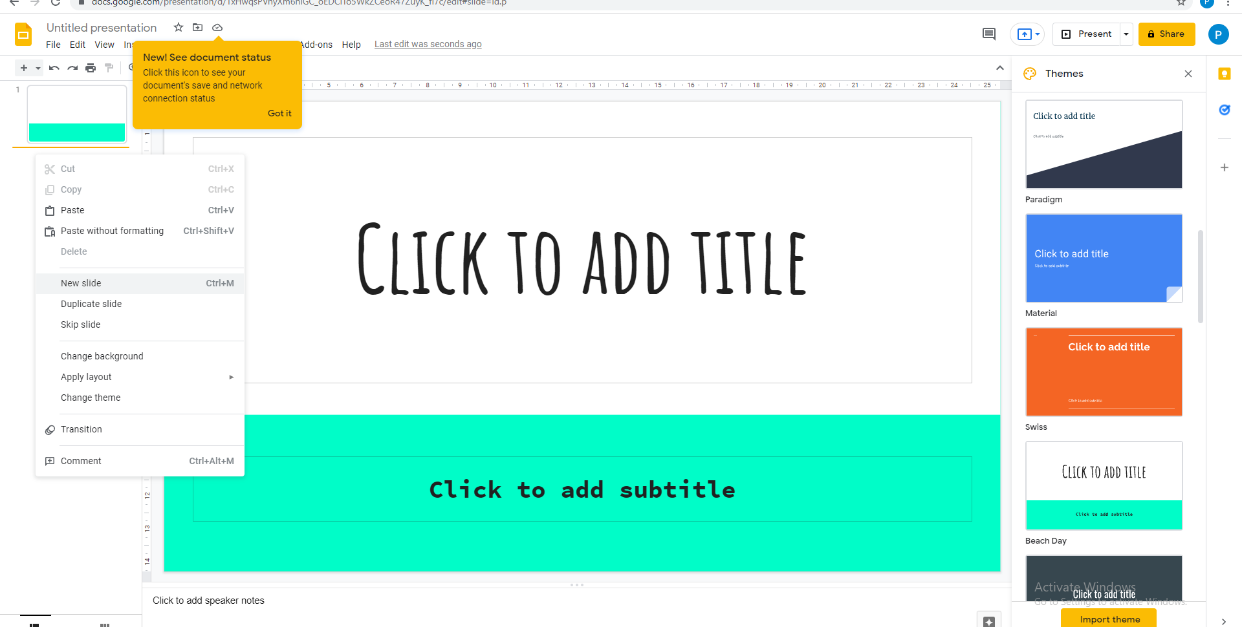
- Fonts can be changed by clicking on the font drop down box. Some fonts allow a certain thickness to be chosen, such as ‘light’, ‘normal’ and ‘bold’.
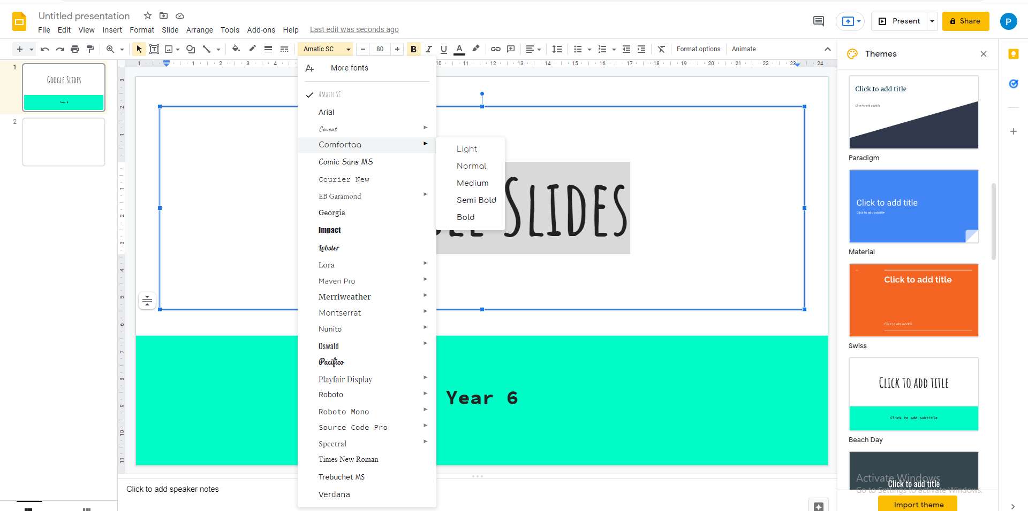
6. How to edit the layout  - The layout of the slide can be edited by clicking on the ‘layout tab’. A variety of layout templates are available to change the positioning of the text boxes and images.  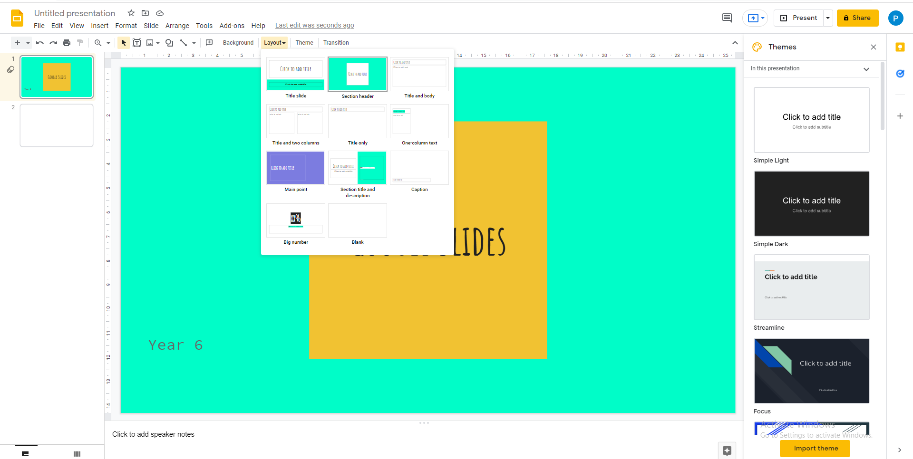 | 9. Self and peer assessment:  - Self and peer assessment are one of the best tools you can use to help you evaluate your presentation.  - It is always worth going back to evaluate the effectiveness of your work, whether that is checking your facts are accurate, ensuring there isn’t too much information to read or making sure you have used transitions effectively.

