Year 6 – Programming
Prior Learning: instructions as algorithms, instructional language, understanding ‘debug’ as correcting mistakes in programing, duplicate function, repeat and loop functions, an understanding of what variables are, coding/programming language and examples of different types .

Facts
1. Controllable Devices  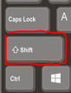  There are now many different controllable devices available. These are small computers that we can program to perform basic and in some cases complex tasks.  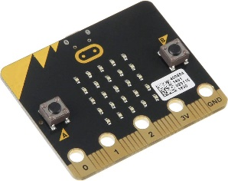  Micro:bit  Raspberry Pi Crumble  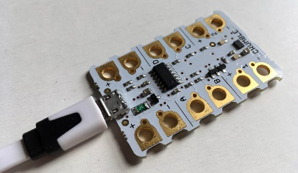  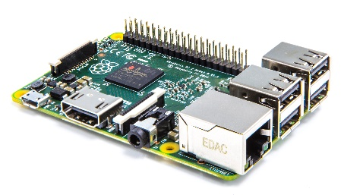 | 3 Senses  There are special components in the devices which can sense. This means they respond to changes in light, temperature, movement and touch  Some can also have an output, such as lights, sounds and movements  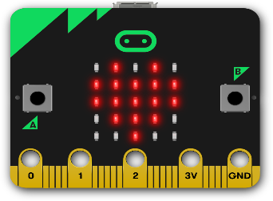  A Micro:bit showing a heart on its dot matrix display
2. Using Scratch to program  Scratch has a dedicated plug in for controlling devices.  Select the add on page  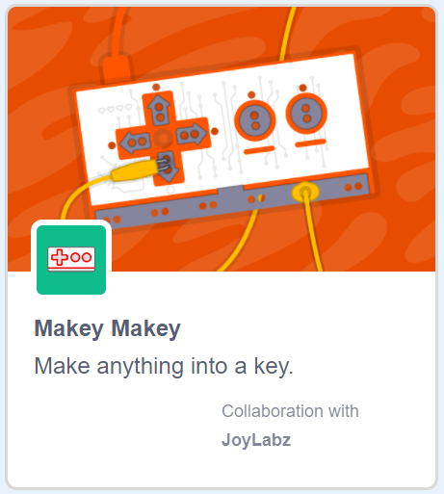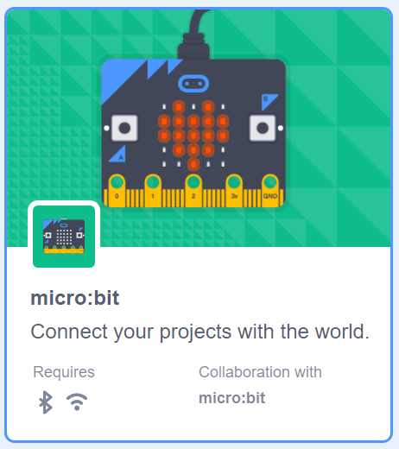  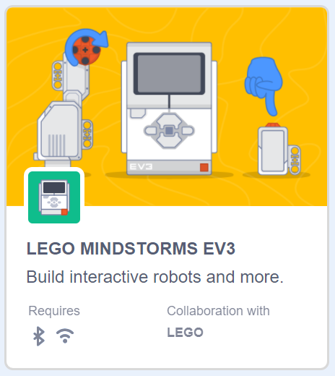  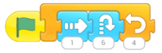  Select the device you need to program for and a new set of command will appear that are linked to that device. | 4 Variables in use with commands  In order to program successfully, variables need to be used with conditions and commands.  Variables can be created and initialised by an input from the user.  Variables must have a unique name so the code can read it.  Variables should have names that are linked to their purpose, this helps when debugging code.  Variables can be updated by events in the code, or by user inputs.  Variables only have one value, when they change that value you cannot undo it or go back.
Vocabulary
Device
Sense
User

