

Ditton Primary Academy

Behaviour Policy Principles, Exclusion Procedures and Anti-Bullying Strategy

Ratified: June 2024

Next Review Date: June 2025



Policy Responsibilities and Review

|  |  |
| --- | --- |
| Policy type: | School |
| Guidance: | Behaviour in Schools – September 2022  Keeping Children Safe in Education- September 2023 |
| Related policies: | School Policies and Procedures:   * + Safeguarding and child protection policy   + Evelyn Street Curriculum statement and guidance   + Relationship education policy   + Code of Conduct (Home/School Planner)   + SEND Policy and statement |
| Review frequency: | Annually |
| Committee responsible: | Local Governing Committee |
| Chair signature: | D Lee |
| Changes in latest version: | KCSIE 2023 updates  Pupil Expectations added (APPENDIX B) |

Contents

1. Purpose 5

1.1 Statement of Intent 5

1.2 Aims 5

1.3 Monitoring and Review 5

2. Leadership and Management 6

2.1 Organisation and facilities 6

2.2 Governance 6

2.3 Head Teacher and Senior Leaders 6

2.4 Behaviour Lead 6

2.5 Welfare Team 7

2.6 Parents 7

3. Systems and Norms 7

3.1 Code of Conduct 7

3.2 Behaviour Expectations Protocols & Lesson Routines 8

3.3 Behaviour Pathways: Rewards and Sanctions 8

3.4 Behaviour Toolkit: 9

3.5 Reflections **Error! Bookmark not defined.**

3.6 Removal from Classroom 9

3.7 Suspension and Permanent Exclusion 10

3.8 Use of Reasonable Force 10

3.9 Banned Items 10

3.10 Discipline Beyond the School Gate 10

4 Pupil Support System 11

4.1 Record Keeping and Data Analysis 11

4.2 Reasonable Adjustments (see SEND Policy and SEND Information Report) 11

4.3 Pupil Transitions 11

4.4 Anti-Bullying Strategy 11

4.5 Child-on-Child Abuse 13

5. Staff Training and Development 13

5.1 Staff Induction 13

5.2 Pastoral Support for Staff Accused of Misconduct 13

APPENDIX A – Code of Conduct 14

APPENDIX B – Pupil Expectations 15

APPENDIX C – Behaviour Pathways - Rewards Document 16

16

APPENDIX D – Behaviour Pathways – Consequences and Sanctions 17

Protocol #1 – Movement Around School 18

Protocol #2 – Start and end of the day 19

Protocol #3 - Lunchtime Routine 20

Protocol #4 – Lesson Routine: PE 21

Protocol #5 – Morning Break Routine 22

Protocol #6 - Use of Defendable Action 25

Toolkit Template A - Reflection Sheet 26

Toolkit Template B – Behaviour Card 27

Toolkit Template C – Positive Behaviour Plan 28

### Purpose

### Statement of Intent

Ditton Primary Academy promotes an environment where all feel safe, valued, happy and secure and where everyone treats each other with courtesy, respect and tolerance where children can learn free from disruption. We believe it is important to encourage children, adults and staff to behave in a caring, co- operative and self- disciplined manner. We expect all members of our school to develop a clear sense of what is right and wrong and care for themselves, others and their environment. We believe that it is the duty of every adult to help to create pupils who are in the habit of self-restraint and self-regulation. Good behaviour is not merely the absence of poor behaviour but involves pupils flourishing as learners and as human beings.

We believe that praise and positive reinforcement are the most important elements of behaviour management and children who display appropriate behaviours must be encouraged and rewarded. Children need to know when they have been successful as this leads to a positive outlook and improved self-esteem, which in turn leads to improved behaviour. As such, children are consistently taught the rules and routines they are expected to follow, and every opportunity is taken to positively reinforce these.

Absolute consistency, clarity and social norms are key to any good behaviour policy. Therefore, we never overlook or fail to act when rules or routines are broken, no matter how time pressured things are.

### Aims

To provide:

* A behaviour culture that reflects Warrington Primary Trust’s guiding principle and core values and that is embedded and enacted in everything we do.
* Strong school leadership, where leaders are highly visible and ambitious goals are set.
* A positive, fair and consistent approach with attention to detail.
* Well established, universally known and well-articulated protocols that are easy to understand and implement.
* Well communicated expectations around praise and positive reinforcement.
* A detailed graduated behaviour code.
* Expectations around the development of effective partnerships with parents and the wider community.
* Engaged staff who receive high quality support and training.

### Monitoring and Review

* This behaviour policy and the associated protocols will be reviewed by the Headteacher, Behaviour Lead and the Full Governing Committee annually.
* Application of the policy will be monitored by the SLT and others within routine school self- evaluation activities.
* The Behaviour Expectations and Pathways will be kept under constant review and updated as required.
* Termly survey data from all stakeholders will be considered.

### Leadership and Management

### Organisation and facilities

Everything we do is carefully planned and structured to give children every opportunity to behave well and succeed. This includes all elements of our education strategy the timetable, the layout of the classroom and shared spaces, exit and entry points, flexible staffing structures, CPD, curriculum and pedagogy.

### Governance

The Local Governing Committee is responsible for a statement of behaviour principles and for holding the Headteacher to account for their implementation. The behaviour link governor is **Rebecca Littler**.

**Local Governing Committee Statement of Behaviour Principles**

* Under Section 88 (1) of the Education and Inspections Act 2006 and in line with the DFE ‘Behaviour and Discipline in Schools - Guidance for governing bodies’, we ensure good behaviour and discipline on the part of pupils are pursued by the school.
* Under section 149 of the Equality Act 2010 we aim to eliminate discrimination.
* Under Section 175 of the Education Act 2002 we have due regard to ensuring we promote the safeguarding and welfare of children.
* We require the school to have due regard to the DFE guidance ‘Searching, screening and confiscation’ January 2018.
* We require the school to have due regard to the DFE guidance ‘Use of reasonable force’ July 2013.
* We require the Headteacher to outline the school’s response to negative behaviour that occurs beyond the school gate.
* We require the Headteacher to apply the WPAT policy ‘Allegations of Abuse’ in the case of staff accused of misconduct.
* We expect the school to be proactive in working with other agencies, particularly for pupils who display continuous disruptive behaviour.

### Head Teacher and Senior Leaders

The Headteacher has overall responsibility for ensuring the safety and well-being of all pupils and adults. Senior Leaders are released each day to monitor behaviour to support CPD and ensure this curriculum is consistently being taught. In addition, the team are visible to our families on the school gate at the start of the day, alongside the SENDCo and other members of the Welfare Team.

### Behaviour Lead

The Behaviour Lead has delegated responsibility for monitoring the impact of policies and initiatives, supporting staff with the day-to-day management of behaviour across the school, overseeing record keeping and reports and the analysis of data. All staff have the delegated responsibility to maintain a safe, calm, and purposeful learning environment. Every adult must always set an excellent example to pupils, modelling and teaching the behaviour they wish to see. They work hard to know their pupils well, understanding that high quality relationships are key to successful behaviour management.

### Welfare Team

The Welfare Team co-ordinate and collaborate, so that there is a joined-up approach to the early identification of and response to individual needs:

* + 1. Headteacher and DSL Trained: **Janette Pyne**
    2. Behaviour Lead: Graeme Bourque
    3. SENDCo: **Paula Bate**
    4. PP Lead: **Dan White**
    5. Pastoral Lead/Deputy DSL: **Katie Scott**
    6. Attendance Officer: **Claire Noone**
    7. Medical Lead: **Mairead King**

### Parents

The role of parents is crucial in helping to maintain good behaviour. We encourage all of our parents to know and reinforce the behaviour policy at home as appropriate. Where a parent has a concern about management of behaviour, they should raise that directly with their child’s class teacher so that we may continue to work in partnership with them. This is also an expectation of parents of children whose behaviour is becoming a concern, as parents are required to meet with different member of the Welfare Team as part of our restorative conversations.

### Systems and Norms

Within our systems and norms we have 4 critical documents. These include our:

1. Code of Conduct
2. Behaviour Expectations
3. Lesson Routines
4. Behaviour Pathways

These cover clear structures around rules, routines and consequence systems

### Code of Conduct

Our Code of Conduct (Appendix A) reflects the guiding principles and the core values of WPAT. It conveys the school’s expectations and understanding for children, staff, and visitors. It is highly visible throughout the school, constantly referred to and explicitly taught:

1. Listen
2. Do as asked
3. Work and play well together
4. Try as hard as you can

We work with parents/carers to foster good relationships between the school and home through good communication. This includes the policy and protocols being clearly accessible on the school website and constantly referred to during all parent meetings. We ask our parents/carers to know the school code of conduct and support their children in following them. We share our high expectations around routines, attendance, time keeping, uniform, homework etc. and work together to achieve the best possible outcomes for children.

We proactively work with other agencies as soon as we become aware of any issues, and we support families together is a range of ways e.g. Early Help, referrals to family support etc.

### Behaviour Expectations Protocols & Lesson Routines

Behaviour expectations (Appendix B) covers what we expect the children to do. We have generated a slide which covers what the children should do within school. We also specific routines to explain what should happen when at different points throughout the school week.

Lesson routines relate to the different routines within a particular subject, particularly those that require the children to move to an alternate room within the building or to use varying pieces of equipment.

These can be found within our various Protocols towards the end of the document.

|  |  |
| --- | --- |
| Number | Protocol |
|  |  |
| 1 | Movement Around School |
| 2 | Classroom Routine |
| 3 | Lunchtime Routine |
| 4 | Break and Lunchtime Play Routine |
| 5 | After School activities Routine |

### Behaviour Pathways: Rewards and Sanctions

Our behaviour paths outline the rewards which our children will receive and the most likely situation they will be awarded for, as well as an overview of the sanctions that will be issued within certain scenarios. We have adopted a graduated response with increasing gains with rewards and severity for sanctions. See Appendix C and D.

We believe that praise and positive reinforcement are more effective than sanctions. Outstanding behaviour is expected at all times, held in high regard by all and constantly promoted and rewarded.

**Ditton Dots**

Children are awarded Ditton Dots by staff when showing good behaviours in school. These are tallied weekly by teachers and contribute towards a whole class reward. Whole class rewards should be no longer than 1 hour in length and are agreed and displayed in class at the beginning of each half term. Whole class rewards occur at age appropriate intervals:

EYFS- Weekly Rewards

KS1- Every 3-4 weeks

KS2- Once very half term.

### Behaviour Toolkit:

This consists of the following template documents which must be used in-line with this policy:

1. Reflection Sheet
2. Behaviour Cards (Red/Amber/Green)
3. Positive Handling Plan
4. Record of use of reasonable force

These can be found in the Toolkits at the end of this document.

### Reflections

A reflections is a commonly used sanction and is often used as a deterrent for negative behaviour as part of our behaviour pathway. All detentions will occur within the school day during either break or lunchtime, most likely on the same day depending on the time of the incident. We do not require parental consent to issue a detention.

The member of staff who has issued the consequence will supervise the child for the detention. During this time, the child will complete the work from the session in which the incident occurred and a restorative conversation will take place. This conversation will help to ensure the incident does not occur again. Staff will ensure they have had sufficient time to eat their snack/lunch and to use the toilet before their time commences. When children reach upper key stage 2, the reflection will be the full 15 minutes.

If a child receives 2 reflections in one half term, the school behavior lead (Mr Bourque) will phone parents to inform them of this and the next steps to be taken.

If a child receives 4 reflections in a half term, a meeting will take place between Mr Bourque, the class teacher, parents and the child. In this meeting, we will discuss the need for a behavior card to be implemented explaining the process with parents and child. It will also be agreed a suitable review point for this.

**Behaviour Cards**

Some children require extra support with their behaviour. We use a card system that allows the children to reflect at set intervals on their behavior throughout the day. These cards are used when a child has had 4 reflections given in a half term. They are asked to give themselves a score out of 3 for “behavior” and “task” which is agreed with the class teacher. They have a daily target and a weekly target. Weekly targets also accumulate towards the whole class Ditton Dot reward. If they do not achieve their agreed number of weekly targets over a period of a half term, the child will not take part in the whole class reward if given.

Children on behavior cards will remain so for at least a half term.

These cards are monitored weekly by the behavior lead and copies are sent home to parents each week. If there is not sufficient improvement, with the half term, Positive Behaviour Plans will be discussed as a possible next step. All staff are required to complete these cards and the focus is on self-reflection of the child and positive behaviours throughout the week. When a child is at a stage where they are managing their behavior consistently, their card can move from red to amber or to green. These cards follow the same points system but are broken up in to longer segments throughout the day to encourage longer periods of self-management.

### Removal from Classroom

Removal is where a pupil is required to spend a limited time out of the classroom at the instruction of a member of staff. The use of removal should allow for continuation of the current learning task in a supervised setting, i.e. in a partner class as part of our reflective process. Where removal is used as an opportunity to reflect, it may last up to five minutes for a child in KS1 or ten minutes for a child within KS2.

In the event that removal occurs to maintain the safety of a child, then this may last for a longer period of time. During this time, the child will be supervised by a trained adult and educational task will continue where possible. Once the child has had sufficient time to self-regulate, then a restorative conversation will take place and they will be integrated back into the classroom with support from a teaching assistant.

Pupils will not be removed from classrooms for prolonged periods of time without the explicit agreement of the headteacher. Extensive support will be given to the child and their family by the Welfare Team with an aim to improve behaviour so they can be integrated and succeed within the mainstream school community.

### Suspension and Permanent Exclusion

As a tolerant, supportive learning community, suspension and permanent exclusion will only be used as a last resort and will only be used in line with current DfE guidance. The school does not wish to suspend or permanently exclude any child but recognises that sometimes this may be necessary.

The Headteacher is the only person who can suspend and permanently exclude a child. When a child is at risk of suspension or permanent exclusion, we follow the DfE statutory guidance ‘Exclusion from maintained schools, academies and pupil referral units in England’.

### Use of Defendable Actions

In order to maintain the safety and welfare of our pupils, it may sometimes be necessary to use “defendable actions”, as permitted by law. Defendable actions can be used to prevent pupils from hurting themselves or others, from damaging property, from causing disorder or committing a criminal offence. It is only used when all possible options have been exhausted. As with rewards, sanctions, defendable action is used consistently, proportionally and reasonably, by staff, in line with this policy, taking into account children with SEND and the bespoke needs of vulnerable children.

A staff team are trained in the use of defendable action (Team Teach) and if a child’s risk assessment identifies deployment of this approach, this team will be deployed. However, all adults have the power to physically intervene to control or restrain a pupil, if in their professional judgment this is required to prevent pupils from hurting themselves or others, from damaging property or causing disorder.

### Banned Items

The Headteacher and staff authorised by them have a statutory power to search pupils or their possessions, without consent, where they have reasonable grounds for suspecting that the pupil may have a prohibited item. Prohibited items include, knives or weapons, alcohol, illegal drugs, stolen items, tobacco and cigarette papers, e-cigarettes/vapes, fireworks, pornographic images, any article that could reasonably be considered likely to be used to commit a criminal offence, cause injury, damage property or has been banned by the school.

School staff can confiscate any prohibited item found as a result of the search. School staff can also confiscate any item they consider harmful or detrimental to school discipline. School will not be liable for any items that are lost following confiscation; all items are brought into school at parent’s risk.

### Discipline Beyond the School Gate

The school reserves the right to discipline pupils for incidents that occur outside of school in line with our graduated behaviour code and exclusion protocols, detailed elsewhere in this policy. This includes incidents that may occur online.

The Headteacher may notify the police if the behaviour is considered anti- social, criminal or poses a serious threat to another person.

The school will always consider whether this behaviour could be linked to an unmet need and follow the safeguarding policy.

### Pupil Support System

We respect the rights of all children within our setting and recognise that when a child is involved in an incident, either as the victim or perpetrator, we must have a support system in place for them. The Welfare Team make a risk assessment which identifies the support required, e.g. anger management, conflict resolution etc. and who will deliver this. Impact is carefully monitored.

Careful data management and tracking allows for early identification of pupils at risk of failing and preventative measures are put in place. Ongoing monitoring allows for impact to be assessed and strategies adjusted as needed.

### Record Keeping and Data Analysis

We use the CPOMS systems to record behaviour and safeguarding concerns. This allows the timely sharing of information, a joined-up approach and early identification of any issues. It also enables data to be robustly and purposefully integrated by the Behaviour Lead. Staff are all trained as part of our CPD offer. Our Behaviour Lead analyses the data to ascertain patterns and to not only prevent further occurrences of negative behaviour, but to also ensure effective support is given at the earliest opportunity.

### Reasonable Adjustments (see SEND Policy and SEND Information Report)

As an inclusive school, all pupils, staff and visitors should be free from any form of discrimination. The school recognises its legal duty under the Equality Act 2010, in respect of safeguarding and in respect of pupils with special educational needs, and Para 7 of Schedule 1 Education Regulations 2010, to prevent pupils with a protected characteristic from being at a disadvantage. Consequently, our approach may be adjusted to cater to the needs of the pupil. A multi-agency assessment will be considered for pupils who display continuous disruptive behaviour.

### Pupil Transitions

Transitions at all levels are carefully planned based on group and individual needs. As required, additional support from the welfare team is given. Parents/carers are involved and informed as appropriate.

### Anti-Bullying Strategy

We aim to provide a safe and secure environment where all pupils can learn without anxiety. We believe bullying is wrong and endeavor to prevent it by having an ethos in which bullying is unacceptable and where it is each person’s responsibility to prevent it.

Pro-active measures are in place to avoid all forms of bullying, and these are delivered in a range of ways: assemblies and Personal Development curriculum. Within these methods are the resources provided by UNICEF to ensure that use a ‘Rights Based Approach’.

Any incidents of bullying will be dealt with in line with the agreed protocol attached. Violence or threatening behavior or abuse will not be tolerated in any circumstances, physically, verbally or through social media.

In formulating our strategy, we take due regard to the key legislation:

* The Education and Inspections Act 2006 Section 89 of the Education and Inspections Act 2006
* The Education (Independent School Standards) Regulations 2014
* The Equality Act 2010. A key provision in The Equality Act 2010 is the Public Sector Equality Duty (PSED)

Definition:

Bullying may be physical, verbal or (in the case of cyberbullying) written and has three key characteristics:

1. It is ongoing and continuous repeated (not the same as a conflict between two equals or a random, unprovoked, aggressive act).
2. It is deliberate and targeted.
3. It is unequal – it involves a power imbalance it may be physical, psychological (knowing what upsets someone) derived from an intellectual imbalance, or by having access to the support of a group or the capacity to socially isolate.

In addition, we define cyberbullying as: The use of information and communications technology, particularly mobile phones and the internet, to deliberately to upset someone else.

Specific types of bullying include those relating to:

* + Race, religion, belief, culture, or gender.
  + SEN or disabilities.
  + Appearance or health conditions - including maternity or pregnancy.
  + Sexual orientation - including homosexual, gay or homophobic, gender reassignment.
  + Young carers or looked after children or otherwise related to home circumstances.
  + Sexist or sexual.

### Child-on-Child Abuse

Following any report of child-on-child sexual violence or sexual harassment offline or online, we will follow the procedures outlined within our safeguarding policy. **Janette Pyne**, our DSL, will consider each incident on a case-by-case basis, seeking support from external agencies where required.

We advocate high standards of conduct amongst our pupils and staff by modelling use of good manners, courtesy and dignified relationships. We will not tolerate sexually abusive language used as ‘banter’ or something to be expected as part of growing up. Pupils who fall short of these behaviour expectations will receive sanctions in line with the school’s behaviour pathways whilst other investigations by police and/or children’s social care are ongoing.

### Staff Training and Development

We commit to the continuing professional development of staff through robust procedures, including training, performance management and induction. This ensure that all staff are accountable for their decisions, adhere to school rules and protocols and consistently demonstrate school values. Staff receive specific training on how to teach behaviour management within school, this is standalone and repeated throughout the year.

### Staff Induction

We are committed to ensuring that all new staff are fully aware of all policies and routines to ensure consistency. As part of the induction process, new members of staff are introduced to the school’s Manual of Instructions, these documents give clear overviews of the expectations within different areas of the curriculum, of which behaviour is one. Protocols are clearly demonstrated to support understanding and maintain high standards amongst staff and pupils.

### Pastoral Support for Staff Accused of Misconduct

Any allegation of misconduct will be dealt with in line with the WPAT policy ‘Allegations of Abuse.

### APPENDIX A – Code of Conduct

**Golden Rules:**

• Listen

• Do as asked

• Work and play well together

• Try as hard as you can

### APPENDIX B – Pupil Expectations

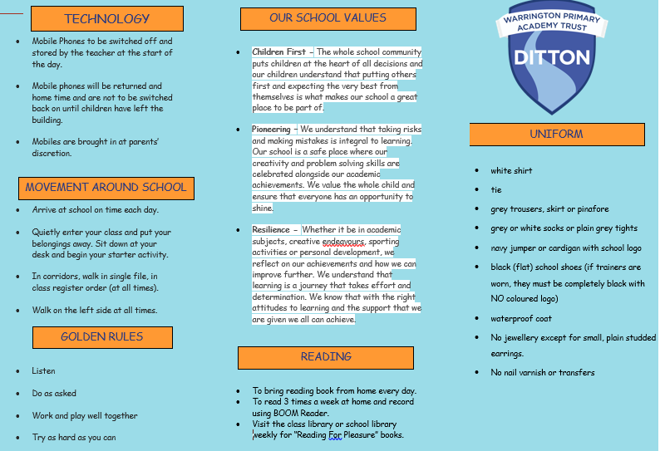

### APPENDIX C – Behaviour Pathways - Rewards Document

|  |  |  |  |
| --- | --- | --- | --- |
| **MAT VALUES** | **CODE OF CONDUCT** | **BEHAVIOUR TO REWARD** | **COMMENDATION AWARDS** |
| Children First  Pioneering  Resilience | Listen  Do as asked  Work and play well together  Try as hard as you can | Be kind  Tidy away resources  Polite behavior  Willingness to contribute in class  Return homework  Finish task in lesson  Use ‘stuck strategy’ when needed  Edit and improve work independently  Truthful answers  Helping others who are struggling  Speaking out at an injustice  Taking responsibility for your actions | Postcards home (one a week per class)  Always Club  Whole Class (Ditton Dot) Rewards |

### APPENDIX D – Behaviour Pathways – Consequences and Sanctions

|  |  |  |
| --- | --- | --- |
| STAGE | PERSON | ACTION |
| Stage 1: Low level incidents:   * shouting out * chatting * wasting learning time * not responding immediately to a   reasonable request   * moving out of seat without permission | Class teacher  Lead adult  TA | * Thinking card * When behaviour is modified, child is praised. |
| Stage 2: Repetition of stage 1 behaviour Or immediately if:   * discourteous * name calling * pushing * unwanted touching of another child * disrupting a lesson * high levels of unnecessary movement | Class teacher  Lead adult  TA | * Time out card- age appropriate time at class reflection table Ks1: 5 minutes   Ks2: 10 mins  Child expected to continue to listen and learn   * Praise any modified behaviour, card removed, child to apologise |
| Stage 3 Continuation of stage 1 or 2 behaviours   * Discriminatory Language   Or immediately if child not compliant to previous sanction (s) | Class teacher Lead adult / TA  Parallel class teacher  Key stage leader Parents | * Break Time Reflection * Completion of a reflection form (sent home with child if they refuse to   complete it)   * Child to complete any missed work during their next break (lunch/break as   appropriate) and to apologise   * Contact with parent/carer at the end of the day * RECORD APPROPRIATELY ON CPOMS |
| Stage 4 Two reflection forms completed in one half term Or immediate if:   * Fighting/ hurting another child * Swearing | Class teacher  Behaviour Lead  Parents | * Child sent to Key stage leader (KS1- CH, LK2- BM, UKS2- ML) * Behaviour Lead informed (after 2 reflections in one half term) and   consideration of behaviour card being put in place. BL will contact the  child’s parents.   * Child to make up lost learning time during break * Parents telephoned (by behaviour lead) to discuss the situation * Child to apologise verbally and/or in writing as appropriate to age etc. * Behaviour Lead to be informed and monitor- consider IBP (Sendco) * RECORD APPROPRIATELY ON CPOMs |
| Stage 5: Continuation of stage 4 behaviours Or immediately if   * Physical assault * Self-harm * Engaging in actions that could harm others * Bullying- all forms * Threatening- high probability of   someone being hurt   * Leaving without permission * Spoiling with intent * Discriminatory Language (with intent) | Class teacher  Behaviour Lead  Parents  Headteacher | Behaviour lead to:   * speak to child and deal with the initial incident * put in place a support plan & risk assessment * consider the involvement of other agencies * speak to parents * sanction appropriate to the incident- loss of full play time or privileges. * RECORD APPROPRIATELY ON CPOMs   Headteacher to be informed and consider, if appropriate, isolation or exclusion |

# Protocol #1 – Movement Around School

* Children should line up quietly, facing the correct direction in a specific order to be determined by the class teacher.
* A member of staff will monitor the line from the back with the leader of the line stopping at agreed points (doors, etc).
* Children will walk slowly and quietly, one behind the other.
* Children and staff should remain on the left when moving around the building.
* If a child requires a staff member’s attention during lining up or transitioning around the school, they will raise their hand and be spoken to when appropriate.
* If children are transitioning around the school alone (e.g., to go to the bathroom) they should walk sensibly and silently.
* When transitioning around the school to go to an assembly, children should follow the above protocols and will be directed where to stand and sit by a member of staff. When directed to sit down, the children are expected to remain silent whilst waiting for the rest of the school to arrive.

# Protocol #2 Start and End Day Routines

# **Start of Day Routine**

# 

# When children are entering the school at the start of the day, the following routines should be followed:

# • At the beginning of the school day, the children enter the building at the assigned door for their class/year group

# • Children are greeted by their class teachers and teaching assistants at the appropriate entrance

# • Upon entering their class, the children can store their coats/ reading bags and lunchboxes within the classroom. All belongings must be neatly stored and nothing must be on the floor or on top of the cupboard

# • Children should walk calmly through the building on their way to class, staying on the left hand side of the corridor.

# • Teachers and teaching assistants use positive praise to reinforce expected behaviours. If a member of staff needs the attention of the children, they will raise their hand and count down from 3. Children should in turn put all equipment down and focus on and listen to the member of staff.

# **End of Day Routine**

# At the end of the school day the following rules and routines should be followed:

# • Before getting ready for home the children will ensure their desks are tidy. Their pencil pots or tray should be organised neatly and all unnecessary items removed from the desks. The children should also ensure the floor around their desks is tidy and that chairs are tucked in

# • Any letters or notices should be handed out to the children to place in their bags. The children will collect their belongings from their cupboards calmly

# • Children will line up near the exit doors ready to leave (Years Rec to year 4- children are dismissed from the classroom and will remain seated with their belongings until their name is called by the adult dismissing).

# • The children must walk

# • When on the playground, the children (Y5 and 6) remain with their teacher (or TA) and wait calmly to be dismissed when a member of staff has seen a parent/carer. If a member of staff needs the attention of the children, they will raise their hand and count down from 3. Children should in turn put all equipment down and focus on and listen to the member of staff.

# Protocol #3 - Lunchtime Routine

# When children are in the dining hall/classroom for dining, the following routines should be followed:

# • Before or upon entering the dining hall, children should wash or sanitize their hands thoroughly.

# • Enter the dining hall in silence and sit at the table as directed.

# • When ready, the member of staff will ask the children on school lunches to line up at the service area. They will line up a table at a time.

# • Children must always walk around the dining room and classroom.

# 

# • When lining up, children should do so calmly and quietly.

# 

# • If children need to use the bathroom during the lunch time, they will ask the member of staff. Children will be given permission to use the allocated bathrooms.

# 

# • Upon finishing their lunch, children should tidy their area by taking their dishes and cutlery to the cleaning station, or by disposing of any waste from their lunchboxes. The children may then return calmly to the playground.

# If a member of staff needs the attention of the children, they will raise their hand and count down from 3. Children should in turn put all equipment down and focus on and listen to the member of staff.

# Protocol #4 – Lesson Routine: PE

# **Before PE**

# • Children should attend school wearing their PE kit on their allocated PE day.

# • P.E is delivered by our P.E coach who will arrive at the class ready to start the lesson.

# • Children will walk quietly to either the hall, court or field ready for the lesson to continue.

# **After PE**

# • P.E coach will escort the children back into class.

# • P.E coach will reiterate the key learning points whilst waiting for the teacher to return.

# Protocol #5 – Morning Break Routine

1. Morning Break:

Classes have a 15 minute break comprising of outdoor play during which time, healthy snacks can be eaten. A member of staff from each class must be present on the playground. Staff are required to circulate all areas and supervise play/behaviour.

2. Lunch time: EYFS have 1 hour for lunch. They eat in the hall for 30 minutes before returning to their outdoor area for 30 minutes play. KS1 and KS2 classes have 45 minutes for lunch. There is a rota in place for which classes go into the hall first and those which go out to play. When the children finish their lunch, they may return to the playground if there is time left in their lunch break. As well as the midday assistants and teaching assistants on duty, there is always a member of SLT monitoring behaviour in the hall, playground and shared areas (corridors, toilets, etc). KS2 lunch times are staggered: LKS2 – 12:00 – 12:45, UKS2- 12:45 – 1:30.

3. Children will be encouraged to use the bathroom during break times. They must ask permission.

Outdoor Play:

• Children should remain quiet until they are outside on the playground

• Members of staff will engage with, monitor and support play; role modelling different games or how to interact with one another

• Designated staff will support the children in specific activities and collection of the play equipment

• Children should make sure that they use the bathrooms at this point in the day

At the end of break time, a member of staff will blow 2 whistles:

First Whistle- All children must stand still.

Second Whistle- All children will walk to their class cone to line up. Some children are assigned to collect and return play equipment to the appropriate box or cupboard. When the classes are lined up they will be met by their teacher who will walk them calmly back to class.

Snack:

• Children should bring their home snacks into the classroom at the start of the school day

• This should be kept in their school bag

• Snack from the kitchen will be collected and brought to the classroom

• All children must wash or sanitize their hands thoroughly

• Staff will monitor home snacks (see healthy school statement and nut free school)

• A member of staff will organise snack being given out children in an orderly fashion

Indoor Play (wet or other):

Each corridor has 4 assigned rooms:

• A “quiet room” for reading, drawing, craft activities, etc.

• A “movie” room where an appropriate film or TV show will be shown on the class interactive whiteboard

• 2 “club” rooms. These rooms will have music playing, board games and more collaborative play activities (Lego, construction, etc)

• A member of staff will monitor each room. The children are allowed to choose their preferred room for wet play but are not permitted to move from room to room. Once they have chosen their room, they must remain in there until playtime has ended or the weather has improved enough for children to play outside.



# Protocol #6 - Use of Defendable Action

* Class teacher makes a judgment and assessment of a situation that arises, and they feel that reasonable force is required to maintain the safety of a child & those around them.
* If a behaviour plan is in place, then the protocols within it should be followed.
* Call for urgent assistance either by walkie talkie asking for support and where needed. If time is of the essence and the safety of the child or those around them is at risk – TAKE IMMEDIATE ACTION!
* Trained colleagues will attend to assist and provide support as required. Their aim is to calm the child, so they are ready to return to their learning, this decision is made by the team delivering support including the child’s class teacher.
* Following an occurrence of defendable action, the child must be checked for any possible marks on their body. This must be done discreetly with the child’s dignity as a priority with TWO adults present.
* Once the child has returned to class. Staff members involved in the incident will be assessed to see if they require time to reset before continuing with their duties.
* All incidents MUST be recorded. Recording of the incident will be completed - this will include an entry on CPOMS, completion of a Positive Handling form and child’s parents notified verbally, followed by written correspondence regarding the incident.
* Inform the DSL who will review the incident and either complete or amend a risk assessment and action plan for the child in the event of future incidents

### Toolkit Template A - Reflection Sheet

**Reflection Sheet**

Take your time to read through each of the questions below. Answer them as fully as possible so that the school senior leader can discuss your actions with you at the end. You will need to complete any work you have missed during the next break time.

|  |  |  |
| --- | --- | --- |
| Reflect | What happened? |  |
| What did I do? |  |
| What did other people do? |  |
| What could I do better next time? |  |
| **Contact with parents** | **Teacher comments:** |

TOOLKIT TEMPLATE B BEHAVIOUR CARD

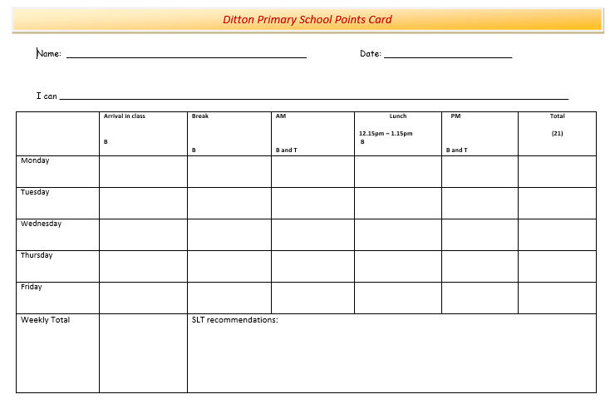

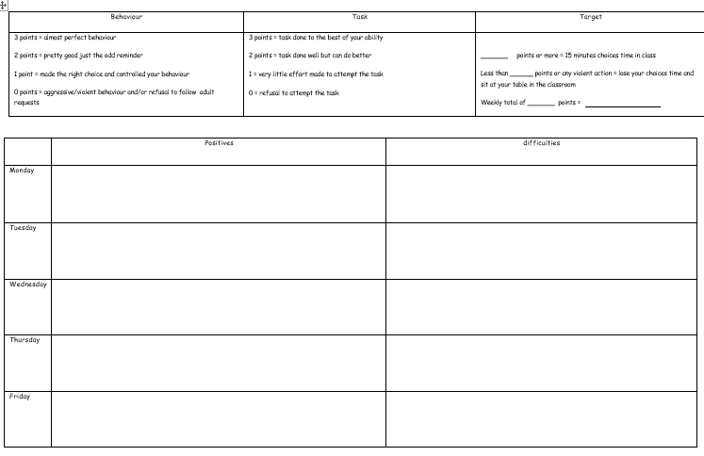

### Toolkit Template C Positive Handling Plan