Subject: Science - Year 2 Year: KS1 Animals including humans (basic needs)
NC/PoS:
- notice that animals, including humans, have offspring which grow into adults
- find out about and describe the basic needs of animals, including humans, for survival (water, food and air)
- describe the importance for humans of exercise, eating the right amounts of different types of food, and hygiene.
Prior Learning (what pupils already know and can do)
Animals can be grouped into amphibians, reptiles, birds, mammals and fish. Different animals have different diets depending on whether they are a carnivore, herbivore or omnivore.
End Goals (what pupils MUST know and remember)
- Know all animals, need food, water, air, and shelter
- Know animals, need to stay fit by eating sensibly and taking regular exercise
- Know all animals, need to eat a balanced diet
- Know the food groups are carbohydrates, proteins, fats, fruits and vegetables and dairy
- Know all animals, have offspring which then grow into adults
- Know some offspring are different from their adults e.g., caterpillar-butterfly, tadpole-frog
- Know the four stages in a life are: birth, growth, reproduce and death
- Know animals also need exercise and sleep to keep a body healthy
- Know humans are hygienic to stop the spread of germs
Key Vocabulary:
offspring, adult, calf, cub, lamb, colt, chick, duckling, piglet, kid, kitten, puppy, kit, birth, growth, reproduce, death, metamorphosis, life cycle, food, water, air, oxygen, survive, survival, shelter, : food groups, fruits and vegetables, carbohydrates, proteins, dairy, fats, balanced diet, sleep, exercise, hygiene, germs, physical
Session 1: review prior learning
Animals can be grouped in amphibians, reptiles, birds, mammals and fish. Discuss structures of these animals. Different animals have different diets depending on whether they are a carnivore, herbivore or omnivore. Name animals that are carnivores, herbivores and omnivores.
Introduce careers: wildlife biologist,
sports scientist https://www.youtube.com/watch?v=mG7B_Y_-HAk
medical physicist https://www.youtube.com/watch?v=IF0WqVk0cTY (up to 1 minute)
Session 2: Recap: Name examples of fish: trout, salmon, cod, plaice; examples of amphibians: frog, newt, toad; examples of reptiles: lizard, snake, turtle, alligator; examples of birds: sparrow, blackbird, robin; examples of mammals: humans, dog, rat, bear
Lo: to identify the offspring of animals
Match photographs of adult animals with their offspring
All animals have offspring which grow into adults.
Vocabulary: offspring, adult, calf, cub, lamb, colt, chick, duckling, piglet, kid, kitten, puppy, kit,
Session 3: Recap: offspring with corresponding adult
Lo: to ask questions about growth in animals
https://www.youtube.com/watch?v=vDDDwfvVUe4 animal life cycles
https://www.bbc.co.uk/bitesize/topics/z6882hv/articles/zd4dkty how animals grow
Videos include various lifecycles: caterpillar, frog, human, chicken
Four stages are: birth, growth, reproduce, death
Children ask questions about other animals’ lifecycles: are all lifecycles the same length? Which animal has the shortest life cycle? What is a baby squirrel called? Etc.
Children record their questions and research the answers

Vocabulary: birth, growth, reproduce, death, metamorphosis, life cycle
Session 4: Recap: What are the four stages in an animal’s life?
LO: Researching what all animals need to survive
https://www.bbc.co.uk/bitesize/topics/z6882hv/articles/z343f82 how do animals survive
https://www.youtube.com/watch?v=YO1K4Tkhp50 basic needs of animals – great images
- Water - need fresh water for their bodies to function. It is vital.
- Food - need food to provide energy to existing cells and to provide the raw materials and energy for the construction of new cells.
- Air – need oxygen to live and there are also air pockets in soils and water that help tiny living things survive in water and beneath the soils.
N.B. all need a place to shelter
Vocabulary: food, water, air, oxygen, survive, survival, shelter
Session 5: Recap: what do all animals need to survive?
LO: identifying food groups to keep the body healthy https://www.youtube.com/watch?v=sQN8HWl6Svk up to 1.34
- Children record the different food groups and food which belongs in them
- Design a healthy lunch box
- N.B. Eat different foods, including fresh fruit and vegetables. Five portions of these per day is best! Drink 6-8 glasses of water every day
Vocabulary: food groups, fruits and vegetables, carbohydrates, proteins, dairy, fats, balanced diet, water
Session 6: Recap: the food groups and name at least two foods for each group
Lo: to identify ways to keep the body healthy
https://www.youtube.com/watch?v=sQN8HWl6Svk from 1.34
https://www.youtube.com/watch?v=UxnEuj1c0sw includes hygiene
Get around one hour exercise every day
Sleep well. It is best to try and sleep for 8-10 hours at night.
Keep yourself as clean as possible. Wash your hands before eating and after using the toilet. Cover your mouth when you sneeze
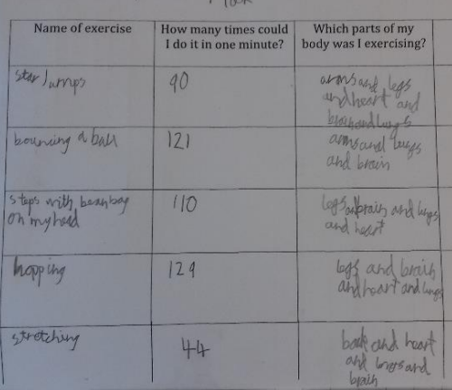
Lo: to explore different types of activities and their affect on the body
Children can explore different physical activities and how it affects their bodies
Vocabulary: sleep, exercise, hygiene, germs, physical
Link to career:
wildlife biologist,
sports scientist https://www.youtube.com/watch?v=mG7B_Y_-HAk
medical physicist https://www.youtube.com/watch?v=IF0WqVk0cTY (up to 1 minute)
Scientists who have helped develop understanding in this field: Aristotle

