Subject: Science Year: LKS2 Year 4 – Living things and their habitats
NC/PoS:
- Recognise that living things can be grouped in a variety of ways.
- Explore and use classification keys to help group, identify and name a variety of living things in their local and wider environment.
- Recognise that environments can change and that this can sometimes pose dangers to living things.
Prior Learning (what pupils already know and can do)
Know that living things all use the following processes: movement, respiration, sensitivity, growth, reproduction, excretion and nutrition. Name a variety of common wild and garden plants, including deciduous and evergreen trees. Name a variety of common animals including fish, amphibians, reptiles, birds and mammals. Describe and compare the structure of a variety of common animals: fish – have a backbone, gills and fins; amphibians – have moist, skin that absorbs water and oxygen; reptiles – have tough scales and lungs for breathing air; birds- light skeletal system and muscles to help it fly: mammals- have hair or fur, females produce milk for their young. Name a variety of plants and animals in their habitats.
End Goals (what pupils MUST know and remember)
- Know examples of how living things can be grouped – invertebrates (no backbone) vertebrates (have a backbone) and plants can be classified into flowering and non-flowering plants
- Know how to use a classification key to help group, identify and name a variety of living things – e.g. Can it fly, does it crawl, does it belong in…
- Know how to identify invertebrates (annelids, sponges, echinoderms, insects, molluscs, crustaceans, arachnids) and vertebrates (amphibians, birds, fish, mammals, and reptiles)
- Know how environments can change and how it can potentially pose a danger to living things -global warming, litter, oil spill, chemical pollution, deforestation, and land development
- Know environments can change and have a positive effect – nature reserves, parks and gardens, community gardens and ponds
Key Vocabulary: vertebrate, invertebrate, backbone, molluscs, annelids, arachnids, crustaceans, echinoderms and insects, classification key, antennae, segmented body, woodlouse, centipede, beetle, flowering, non-flowering, algae, mosses, ferns and coniferous trees, grasses, shrubs, cereals and deciduous trees, negative, positive, global warming, litter, oil spill, chemical pollution, deforestation, land development, nature reserves, parks and gardens, community gardens, ponds
Session 1: Recap session
Revisit living things all use the following processes: movement, respiration, sensitivity, growth, reproduction, excretion and nutrition.
Revisit: names of common wildflowers – dandelion, forget-me-not, cornflower; garden flowers – rose, fuchsia, geranium; deciduous trees – ash, oak, beech, silver birch, alder; evergreen trees pine, spruce, cedar
Revisit comparing the structure of a variety of common animals: fish – have a backbone, gills and fins; amphibians – have moist, skin that absorbs water and oxygen; reptiles – have tough scales and lungs for breathing air; birds- light skeletal system and muscles to help it fly: mammals- have hair or fur, females produce milk for their young.
Revisit plants and animals in their habitats.
Vocabulary:
Session 2: Recap: Name and identify common wildflowers, garden flowers and trees from session 1.
Children learn that vertebrates have a backbone and include fish, amphibians, reptiles, birds and mammals. Invertebrates include snails and slugs (molluscs), worms (annelids), spiders (arachnids), crustaceans, echinoderms and insects.
Suggested resources:
https://www.youtube.com/watch?v=bsjP3940BHA invertebrates from 4:18
https://www.bbc.co.uk/bitesize/topics/z484382/articles/z8mbqhv what is an invertebrate?
https://www.bbc.co.uk/bitesize/topics/z484382/articles/zp6g7p3 what is a vertebrate?
Children sort photographs using a classification key

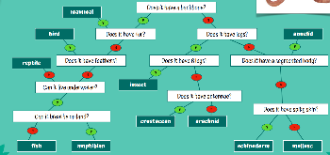
Vocabulary: vertebrate, invertebrate, backbone, molluscs, annelids, arachnids, crustaceans, echinoderms, sponges and insects, classification key
Session 3: Recap: What are the vertebrate groups? Name the invertebrate groups.
Children learn to use a classification key to identify animals in their local environment.
Suggested resources:
Use ‘pooters’ to collect any mini-beasts, place cream sheet under bush and gently shake, use magnifying glasses
Children produce their own classification key to sort the animals they found after modelling from teacher.
Vocabulary: antennae, segmented body, woodlouse, centipede, beetle
Session 4: Recap: what animals were found in the local environment?
Children learn plants can be classified into flowering and non-flowering plants. Flowering plants include grasses, shrubs, cereals and deciduous trees. Non-flowering plants can be classified into algae, mosses, ferns and coniferous trees.
Suggested resources:
https://www.youtube.com/watch?v=cgVlrtGnG6s classifying and grouping plants
https://www.dkfindout.com/uk/animals-and-nature/plants/flowering-plants/
https://www.woodlandtrust.org.uk/trees-woods-and-wildlife/plants/grasses-and-sedges/
https://www.dkfindout.com/uk/animals-and-nature/plants/non-flowering-plants/
https://www.woodlandtrust.org.uk/trees-woods-and-wildlife/plants/ferns/
Children sort photographs using a classification key

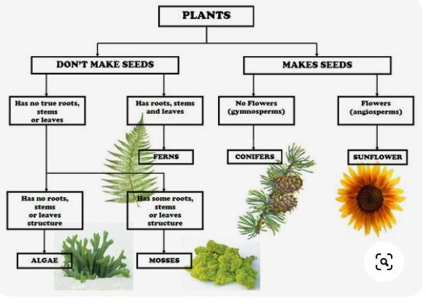
Vocabulary: flowering, non-flowering, algae, mosses, ferns and coniferous trees, grasses, shrubs, cereals and deciduous trees
Session 5: Recap: how might we classify plants? Name types of flowering plants. Name types of non-flowering plants.
Children learn to use a classification key to identify plants in their local environment.
Suggested resources:
Children produce their own classification key to sort the plants they found after modelling from teacher.
Vocabulary: leaves, flowers (plants in local environment – white clover, nettles, grasses, ivy, dog rose)
Session 6: Recap: what plants are there in the local environment?
Children learn environments can change and potentially pose a danger to living things -global warming, litter, oil spill, chemical pollution, deforestation and land development. Environments can change and have a positive effect – nature reserves, parks and gardens, community gardens and ponds
Use ypte.org.uk Living things and their habitats for images
Vocabulary: negative, positive, global warming, litter, oil spill, chemical pollution, deforestation, land development, nature reserves, parks and gardens, community gardens, ponds
Link to career: environmentalist, vet,
https://pstt.org.uk/application/files/2416/2851/6687/Veterinary_surgeon_-_Dr_Kelly_Blacklock.pdf
https://pstt.org.uk/application/files/7716/4942/8554/Biologist_-_Robyn_Grant_v2.pdf
Scientists who have helped develop understanding in this field: Carl Linnaeus

